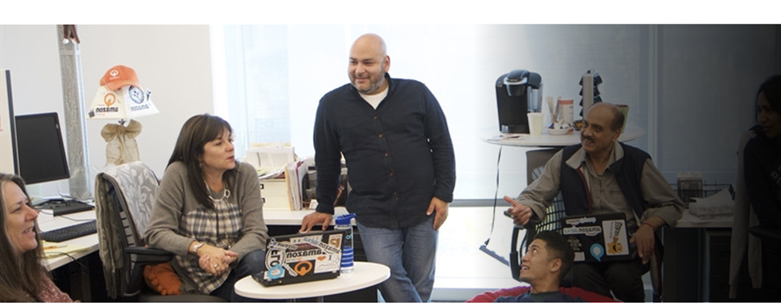  
**Level-up CSP Technical Training – Power Platform Facilitator Guide**

Custom Copilot for Enhanced Customer Experience

Lab Guide for Retail Scenario

|  |  |
| --- | --- |
| Description | This scenario extends the functionality of the Virtual Assistant copilot for Contoso Electronics, initially developed to assist customers with product discovery and post-purchase activities like return eligibility and refund requests. The enhancement introduces automated case escalation, allowing the copilot to seamlessly transfer conversations to live agents when it cannot resolve a query or when the customer requests human assistance. This ensures a more personalized and efficient customer service experience by blending automated responses with human support for complex issues. |
| Prerequisites | To get the most out of this lab guide we recommend you must develop copilot use case 2 (Build a copilot for your customer’s webpage), Microsoft dynamic 365 Customer Service trial license, Copilot Studio, Power Pages trial license and Work, school or Admin Tenant ID - Password. |
| Duration | 30 mins |
| Version | 1.0 |
| Publication date | September 2024 |

This document is provided “as-is”. Information and views expressed in this document, including URL and other Internet Web site references, may change without notice. You bear the risk of using it.

This document does not provide you with any legal rights to any intellectual property in any Microsoft product. You may copy and use this document for your internal reference purposes.

© 2024 Microsoft. All rights reserved.

Table of Contents

Objective & Scenario 3

Objective 4

Solution Focus Area 4

Persona and Scenario 4

Pre-requisites 5

Lab Instructions 5

Exercise1: Configure Copilot with Dynamics 365 6

Task 1: Sign in to Dynamic 365 6

Task 2: Create a New Workstream 9

Task 3: Configure a New Channel 10

Conclusion 13

Exercise 2: Escalate Copilot and Connect Omnichannel 13

Task 1: Configure Escalate Topic 14

Task 2: Activate the Copilot Channel 16

Task 3: Publish Your Copilot 17

Conclusion 18

Exercise 3: Add and Activate Copilot Bot in Dynamic 365 18

Task 1: Add Bot in Dynamic 365 19

Task 2: Check Bot Connection 21

Conclusion 22

Exercise 4: Deploy Copilot on a Power Page Website 22

Task 1: Connect Bot with Power Pages 22

Conclusion 27

Test Live Agent 27

Final Conclusion 30

# **Objective & Scenario**

## Objective

This is an extension of **Use Case 2**, where we developed a standalone Virtual Assistant copilot for Contoso Electronics' webpage to help customers discover the best products based on their needs and preferences, as well as manage post-purchase activities such as verifying return eligibility and submitting refund requests seamlessly. In this use case, the goal is to enhance the copilot by introducing automated case escalation to live agents when the copilot cannot resolve a customer’s issue or when the customer requests human support.

## Solution Focus Area

In **Use Case 2**, the copilot was created and published on Contoso Electronics' website to assist customers with product discovery and post-purchase processes like returns and refunds. Now, the focus shifts towards **enhancing customer support** by enabling the copilot to smoothly escalate conversations to live agents when required. This ensures that customers receive timely and effective assistance when the virtual assistant alone is not sufficient.

The enhancement will focus on:

1. **Automated Case Escalation**: Automatically transitioning the conversation to a live agent when the copilot cannot provide relevant information or fully address the customer’s concern.
2. **Live Agent Requests**: Allowing customers to request live agent assistance at any point during their interaction with the copilot, ensuring they can access human support when needed.

## Persona and Scenario

* **Remy Morris** - Digital Solutions Architect
* **Mark Brown** – Project lead
* **David Flores** – App developer
* **Jane Miller** – App tester
* **Contoso Electronics Support Team** –Live Agents
* **Miriam Graham –** Customer

These personas will participate in the following sequential scenarios:

* Remy Morris designs and plans the digital architecture to meet the business needs. He presents this framework to Mark Brown and helps him select the appropriate Power Platform tools for the implementation.
* Mark Brown provides David Flores with an overview of the selected tools and processes. This includes enhancing the virtual agent with the live agent feature using Copilot, Dynamics 365, and implementing the bot on the Contoso Electronics webpage.
* David Flores creates the virtual assistant, ensuring it meets all the requirements specified by Contoso Electronics. He then submits the developed assistant to Jane Miller for testing.
* Jane Miller conducts thorough testing and validation of the virtual assistant to ensure functionality and performance.
* Upon successful testing, Mark Brown officially deploys the virtual assistant with live agent features on the Contoso Electronics website.
* Miriam Graham initiates interaction with the Virtual Assistant Copilot to inquire about the return policy for her laptop due to unsatisfactory battery life. If the Virtual Assistant Copilot cannot resolve the issue completely or if Miriam prefers to speak with a human, the copilot escalates the conversation to a Live Support Agent.
* The Live Support Agents handle the escalation, addressing any complex issues or detailed inquiries. They ensure Miriam’s refund request is processed smoothly and promptly.

## Pre-requisites

For this use case, all participants will need the following:

* Work, school or Admin Tenant ID and Password.
* Microsoft Copilot Studio Free Trial License
* Microsoft Dynamic 365 Customer Service Free Trial License
* Microsoft Power Pages
* Contoso Electronics Bot Use Case 2 (Build a copilot for your customer’s webpage)

**Note:** Please be aware that the user interface (UI) of Power Apps, Copilot, Microsoft 365, Power Automate, and other related tools may change over time as Microsoft continues to update its products. However, the core concepts and logic behind their functionality will remain consistent. The principles you learn in this lab can still be applied, even if the UI looks different in the future.

# **Lab Instructions**

# Exercise1: Configure Copilot with Dynamics 365

In this exercise, you will set up Dynamics 365 for customer service by signing in, creating a new workstream, and configuring a chat channel. This process will enable you to integrate and manage customer interactions efficiently using Dynamics 365’s capabilities.

## Task 1: Sign in to Dynamic 365 Customer Service

1. Open your preferred web browser and navigate to <https://www.microsoft.com/en-us/dynamics-365/products/customer-service>
2. On the homepage, click the **Try for free** button to initiate the process of signing up for a free trial of Dynamics 365 Customer Service.

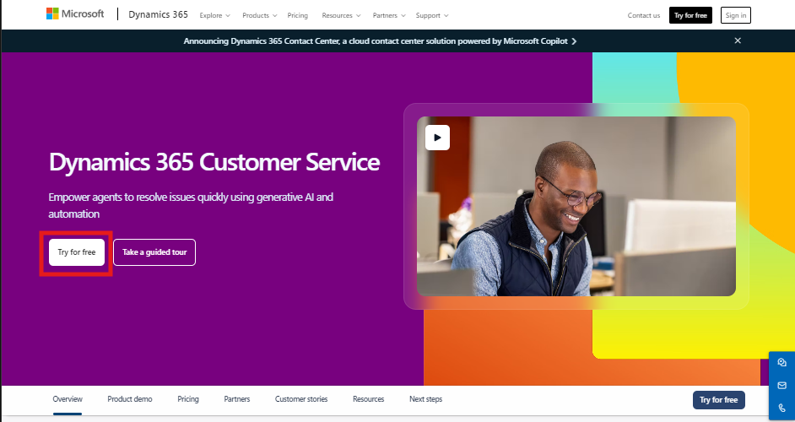

1. After clicking the button, you will be redirected to a page where you need to enter your Work, School or Admin Tenant Email ID (Same Id as Use case 2). For this lab, we use an admin tenant ID, but participants can use any of these options.

Note: This lab is the extended version of **Build a copilot for your customer’s webpage lab,** please use same credential in both the lab.

1. Once you have entered the ID, Select the checkbox and click on Start your free trial to proceed.

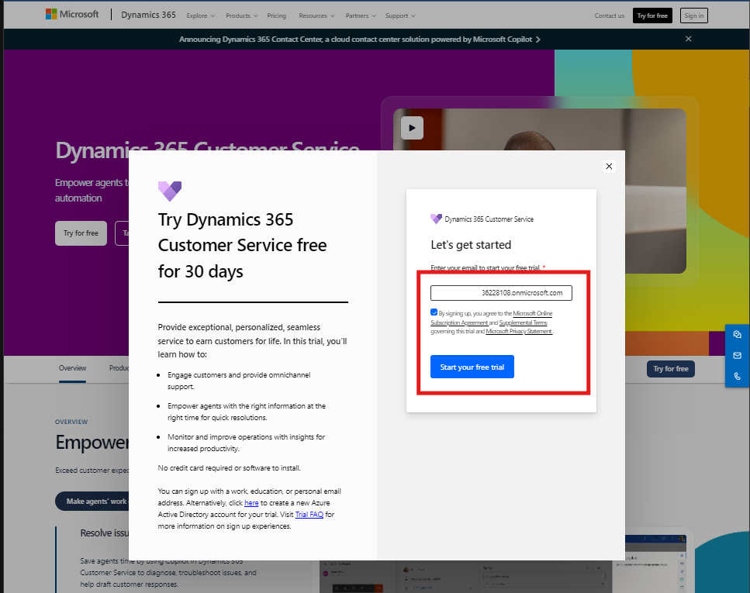

1. Then Enter the password required for the login and then click on Sign in.

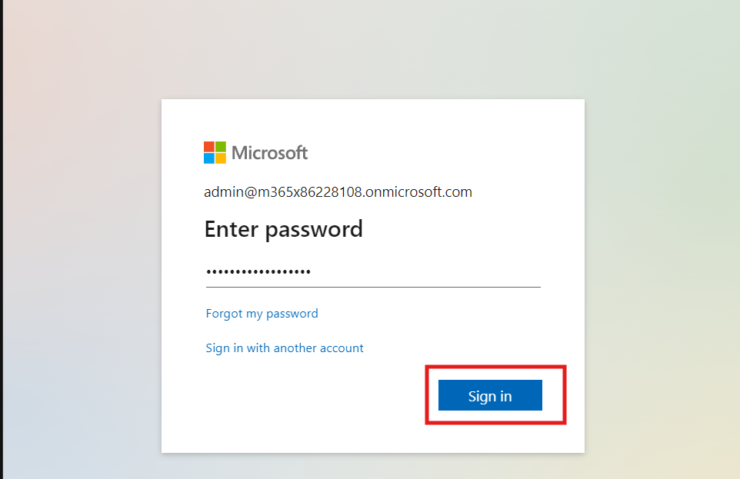

1. On the next screen, you will be asked to provide additional details to complete the setup. Select **Country (We choose United States)** as **region**.
2. Enter your **Phone Number** in the provided field for verification purposes. This helps Microsoft ensure that the trial is being accessed by genuine users.
3. Once all information is entered, click on **Submit** to finalize the setup.

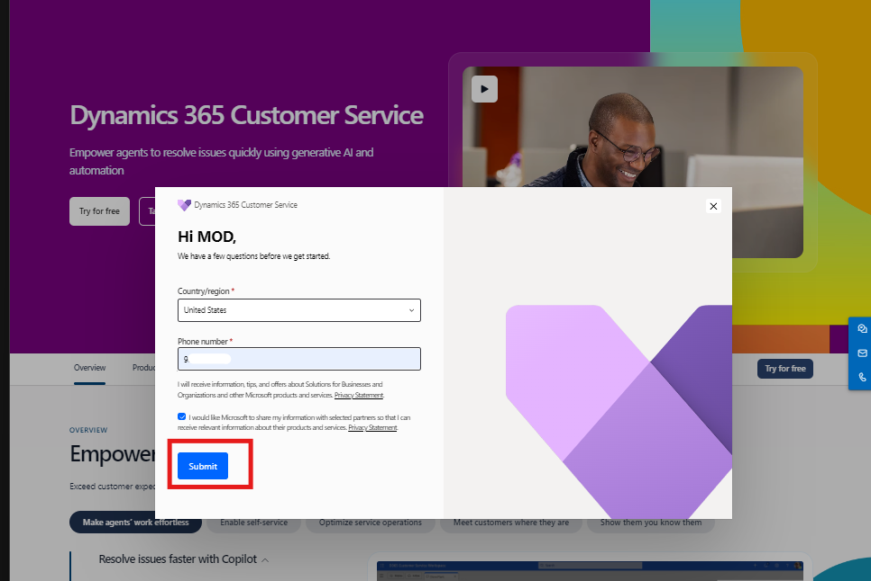

1. After submission, you will be redirected to the Dynamics 365 Customer Service home page.
2. Click on **Customer Service workspace** to explore the tools available.

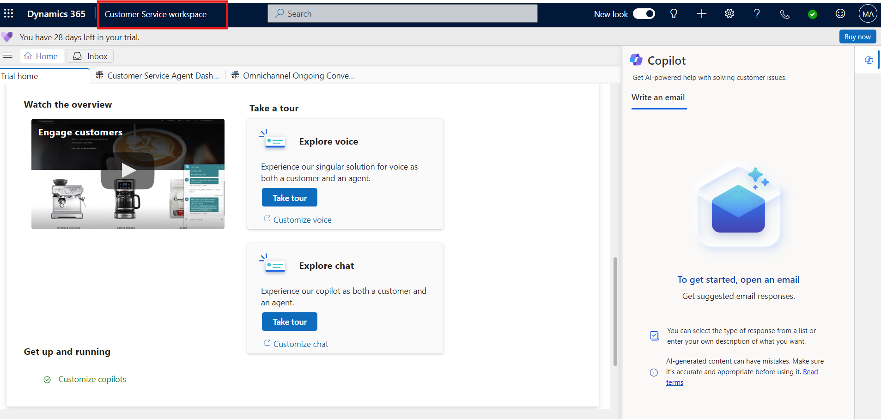

1. Locate and click on **Customer Service admin Center** within the workspace to configure settings, manage users, and customize your customer service setup.

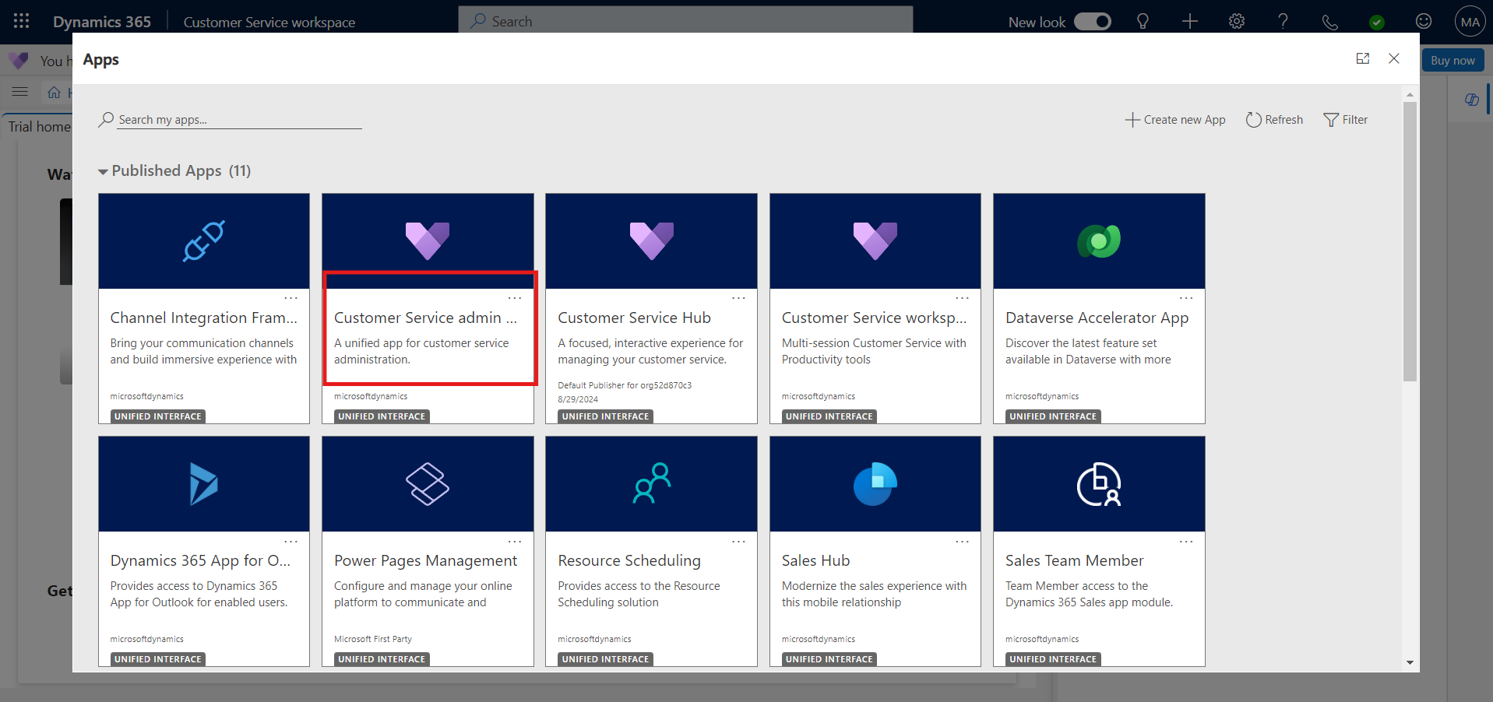

## Task 2: Create a New Workstream

1. In the left navigation bar, click on **Workstream**, then click on **+ New Workstream** to create a new one.

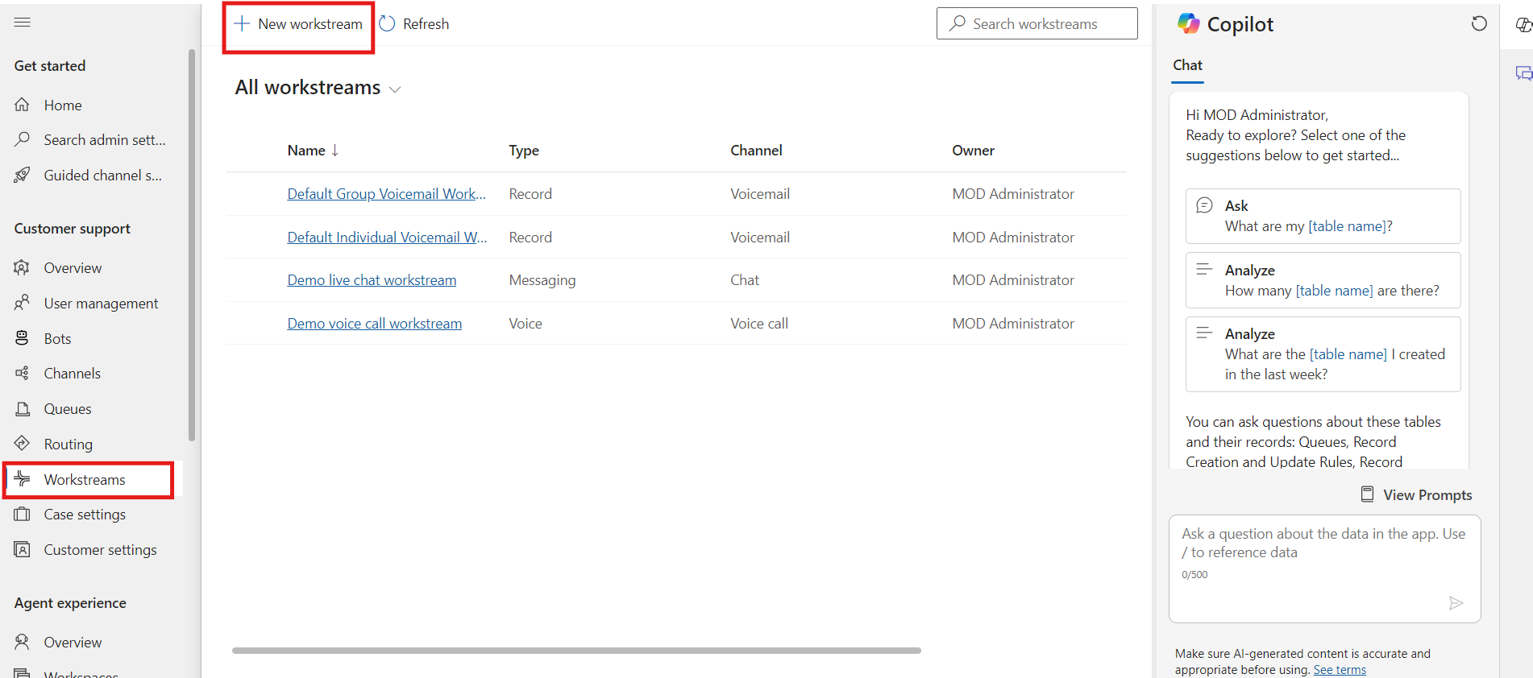

1. Enter **Contoso Agent** in the Name field.
2. Select **Messaging** from the Type dropdown menu.
3. Select **Chat** from the **Channel dropdown** menu.
4. Select **Push** and **Choose Existing** (If already selected no need to perform this step).
5. From the choose existing dropdown menu, select **Fallback-chat demo (1 user)**.
6. Click **Create** to finalize the new workstream. You will be redirect to Contoso agent workstream.

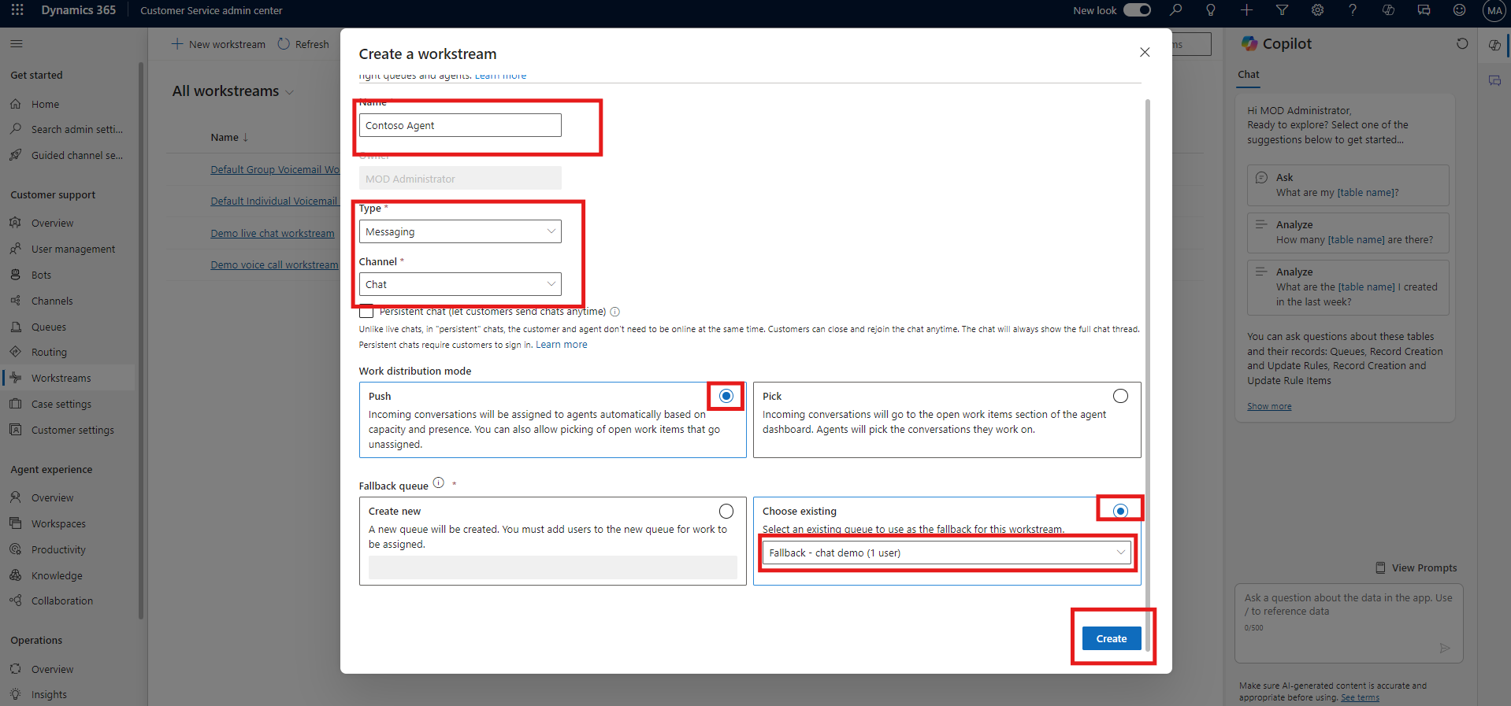

## Task 3: Configure a New Channel

1. In the **Contoso Agent** workstream, click on **Set up chat**.

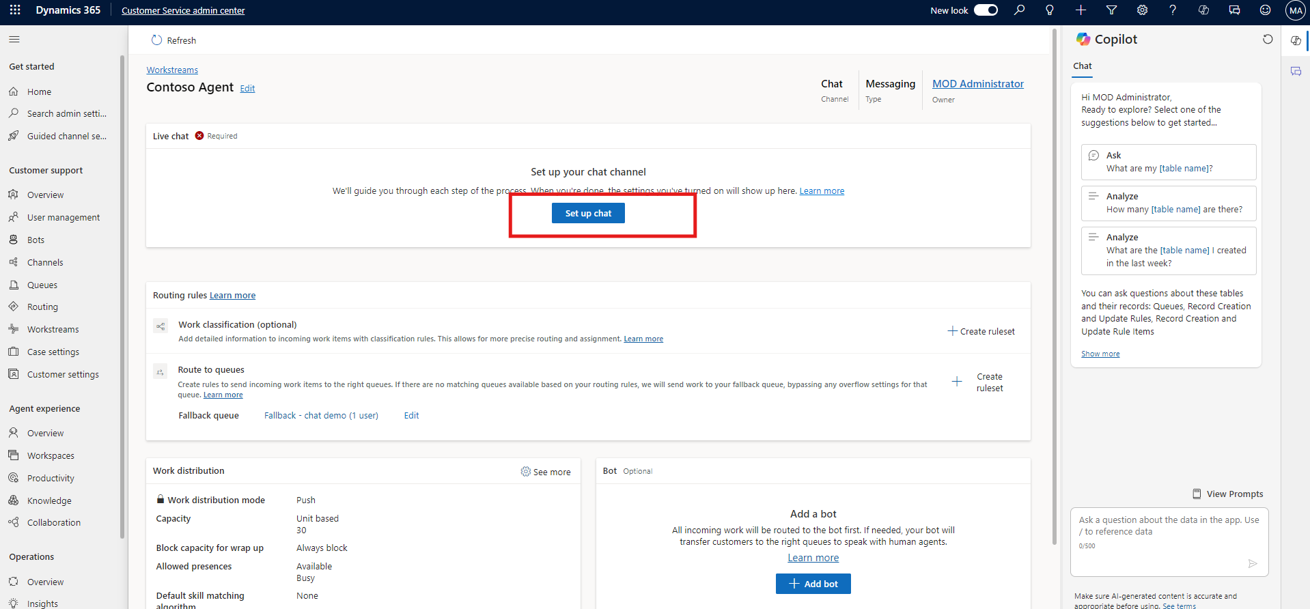

1. Enter **Contoso Live Agent** as the name of the channel. Click **Next**.

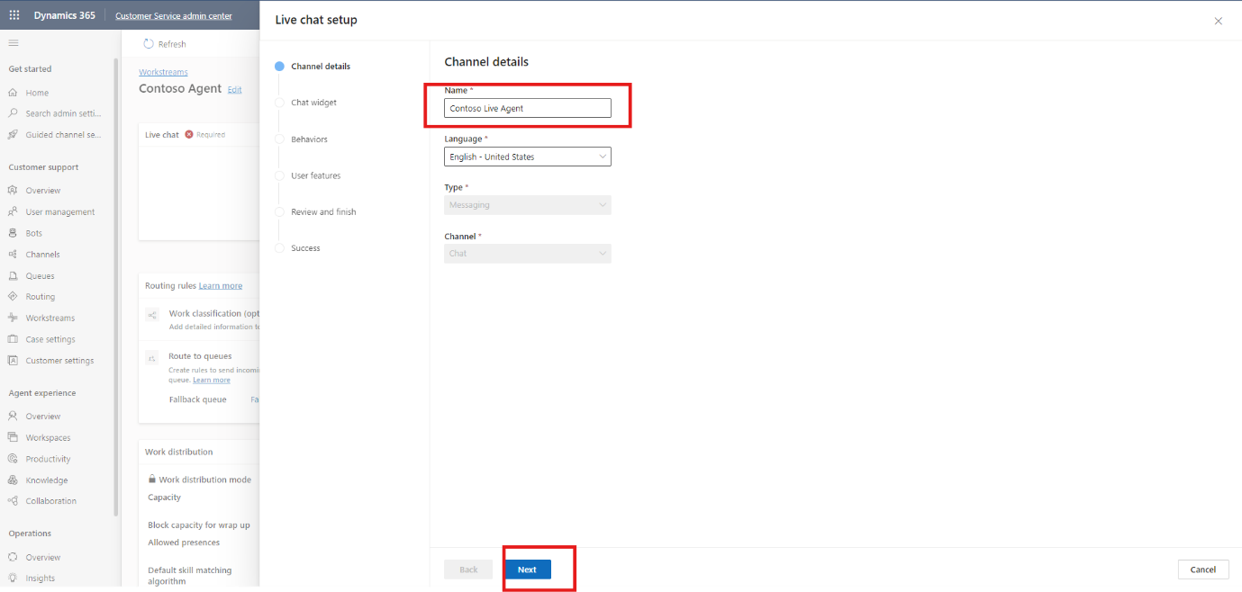

1. Enter **Contoso Agent** in the Title field. Click **Next** again.

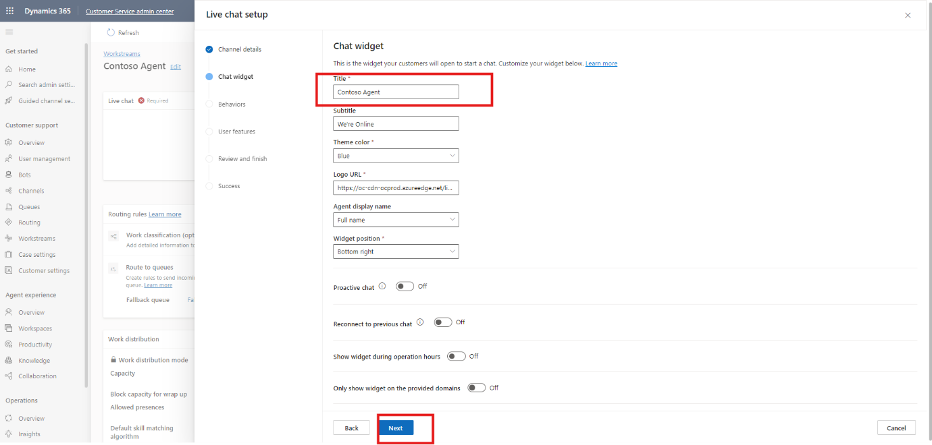

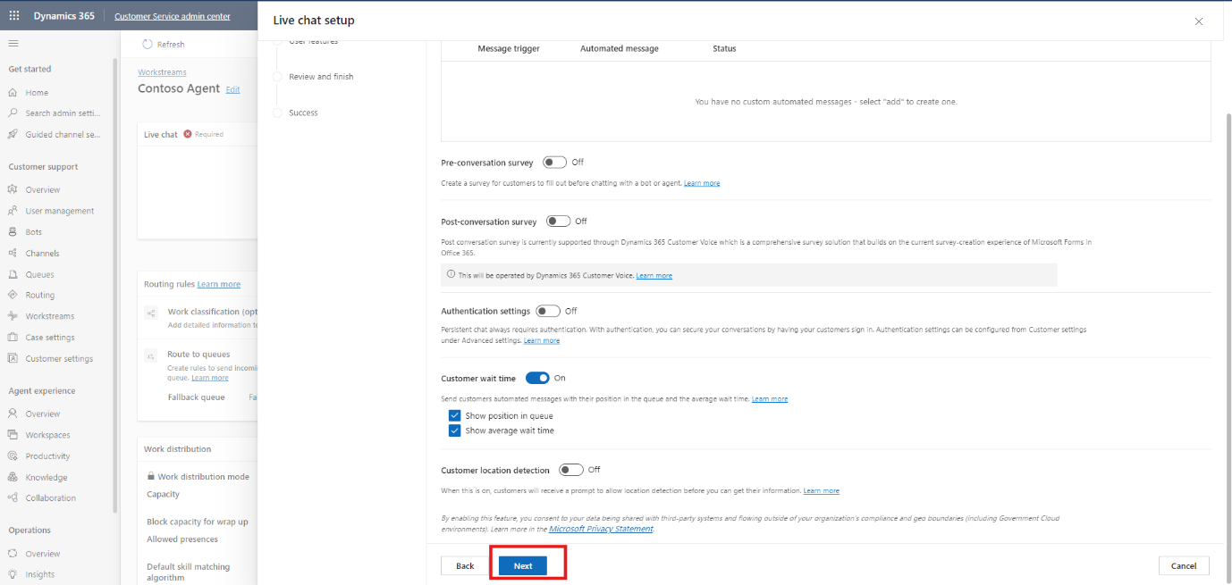

1. On the User Features page, turn off **File attachment** and **Voice and Video Call** options, then click **Next**.

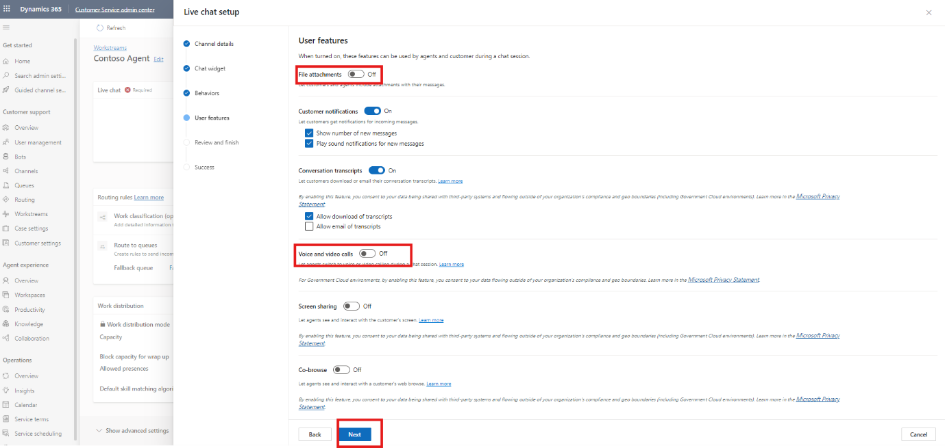

1. Click on the **Create Channel**.

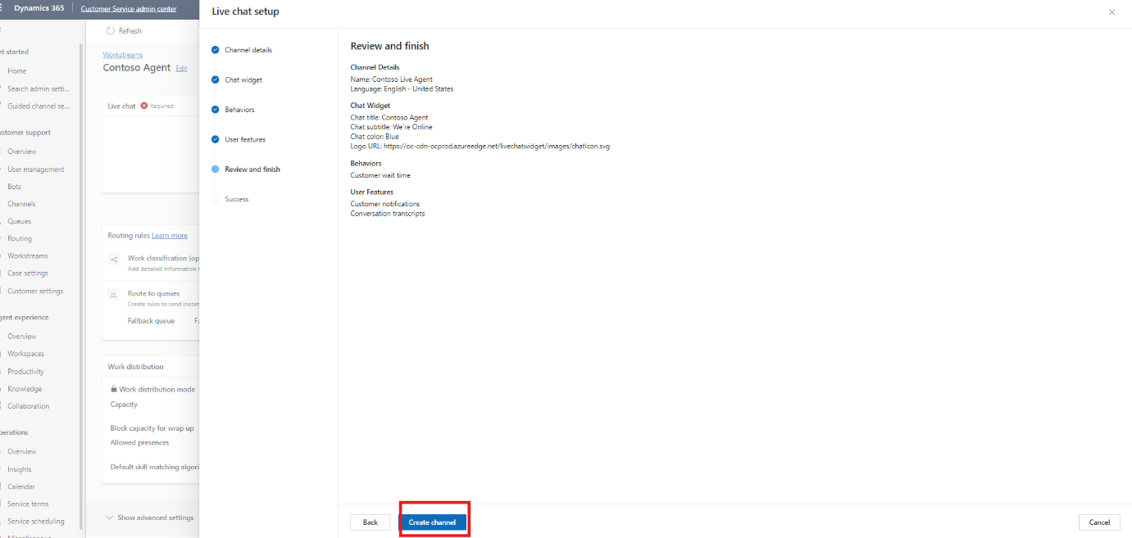

1. Copy the widget code and click **Done**.

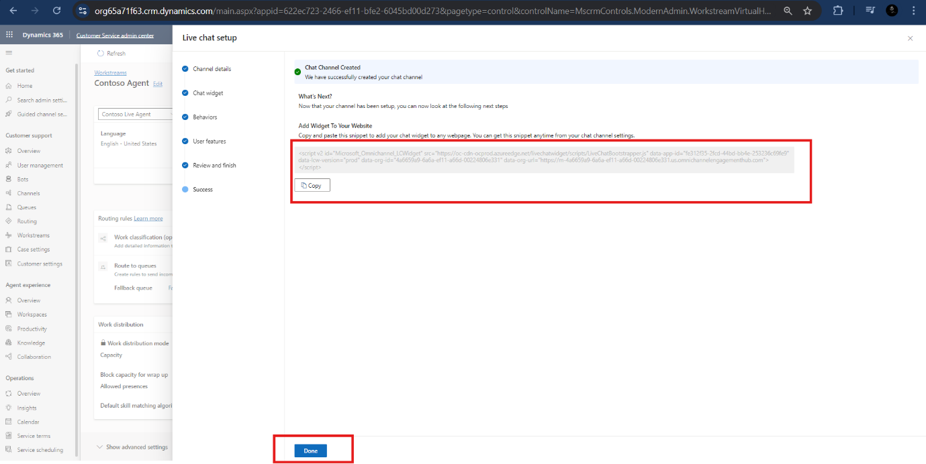

## Conclusion

After completing this exercise, you have gained the following knowledge:

1. Logged into Dynamics 365 Customer Service and accessed the workspace
2. Established "Contoso Agent" with messaging and chat channel settings.
3. Set up "Contoso Live Agent" with specific features and obtained the widget code for integration.

This setup prepares Dynamics 365 for effective customer interaction management.

# Exercise 2: Escalate Copilot and Connect Omnichannel

In this exercise, you'll enhance the functionality of your Copilot by configuring escalation topics and establishing a connection with Dynamics 365. You'll also activate the Copilot channel to ensure seamless integration and communication with the customer engagement hub.

## Task 1: Configure Escalate Topic

1. Navigate to **Copilot Studio** and sign in with same credential which use for the dynamic 365 Customer Service, Select the **CustomerService Trial** environment from top right option.
2. Select your **Contoso Electronics Services Copilot**.
3. In the top navigation bar, click on **Topics** (located next to the knowledge base).

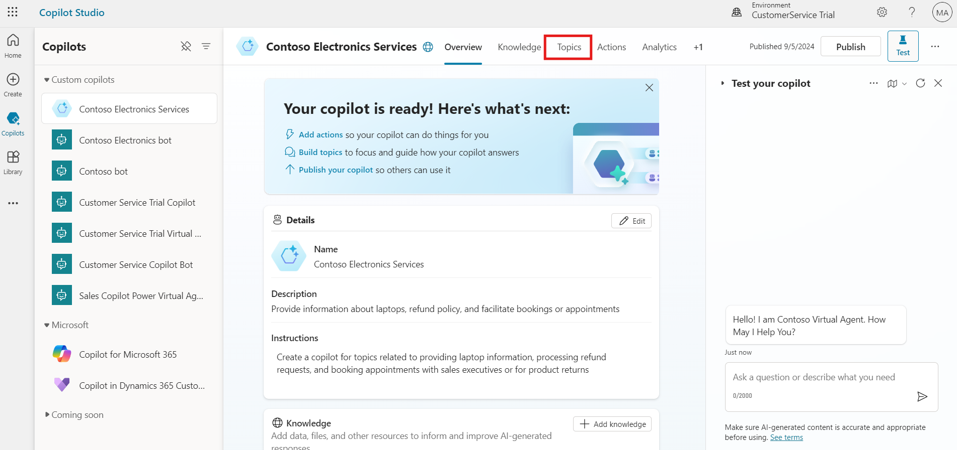

1. Scroll down to locate the **Escalate** topic and select it to open the configuration.

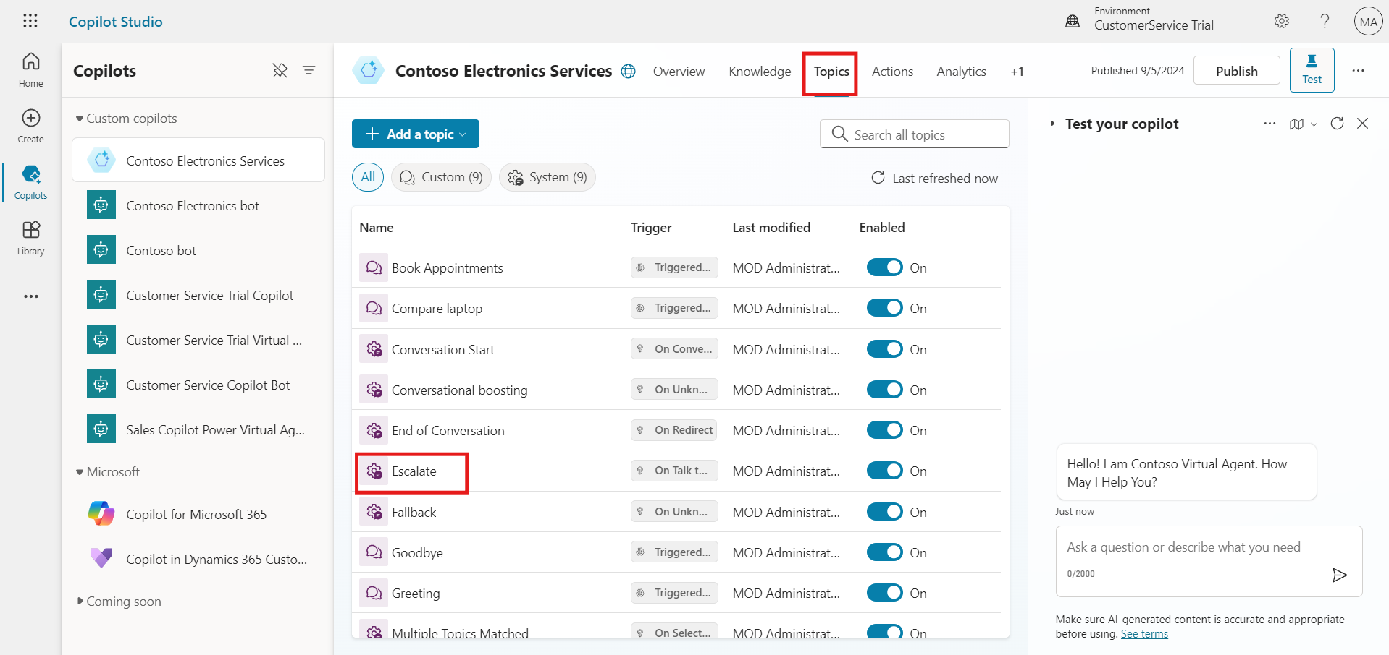

1. In the topic canvas, find the **message node**.
2. Click on the three dots next to the message node and choose **Delete** to remove it.

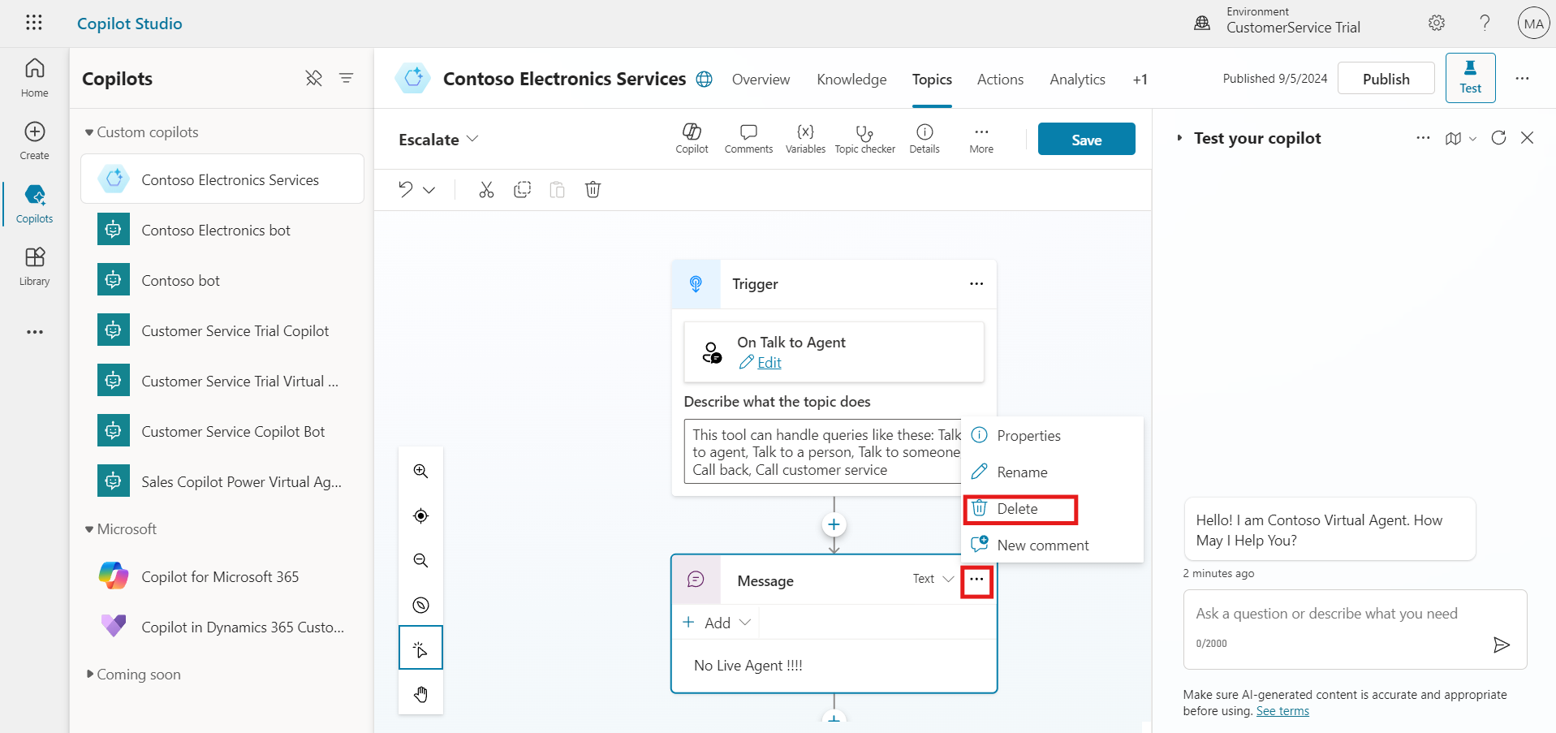

1. Click on the **+ sign** below the trigger node to add a new node.
2. Select **Topic Management** from the options.
3. In the topic management options, select **Transfer Conversation** to create a new transfer node.

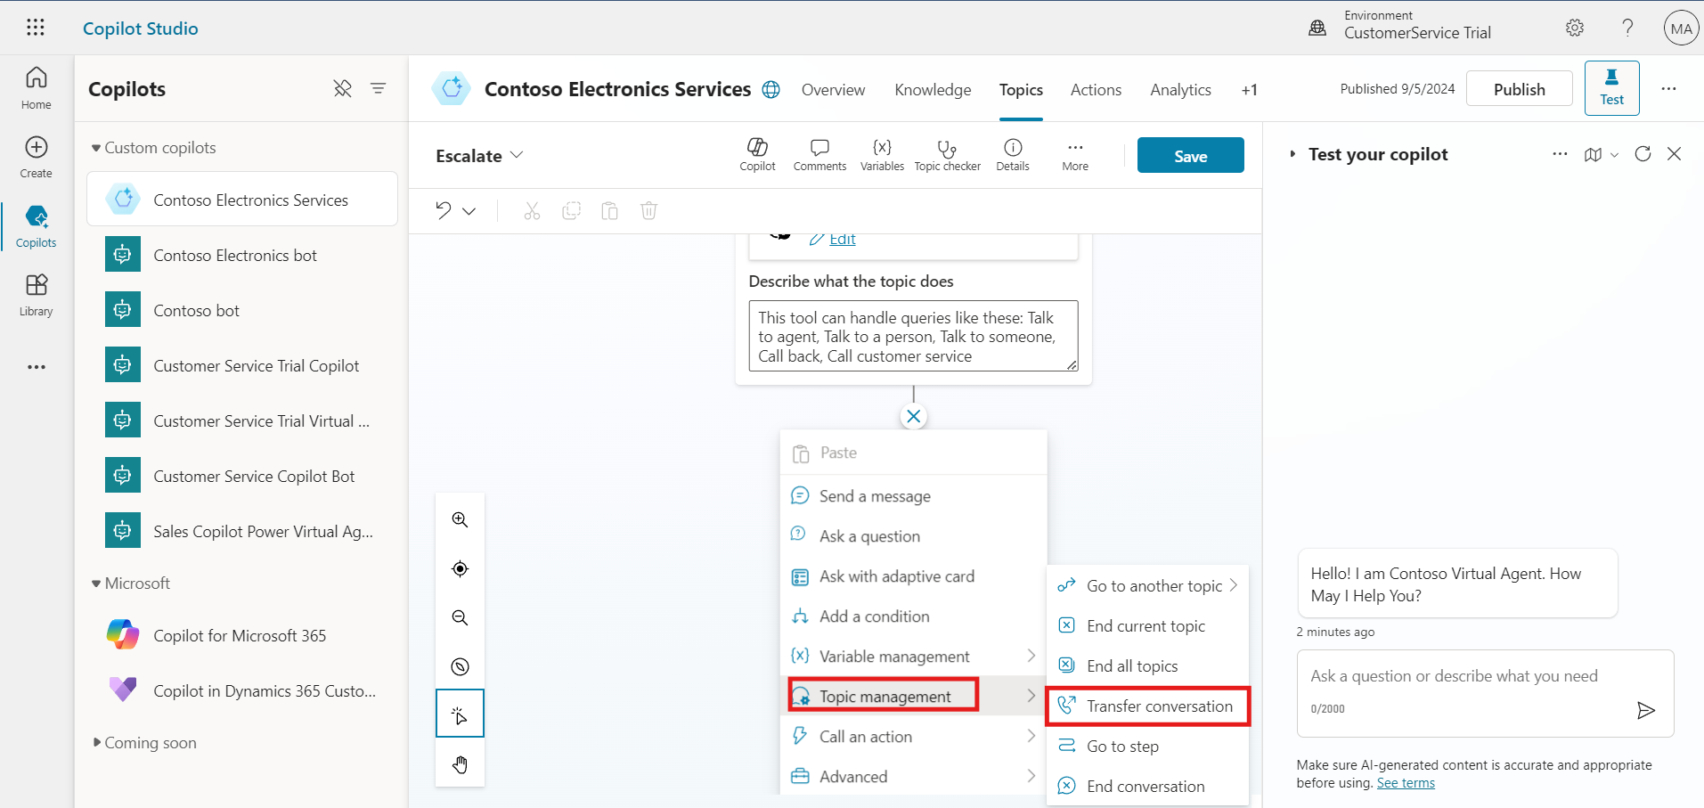

1. Once the **Transfer Conversation** node is added, click the **Save** button to save the configuration changes.

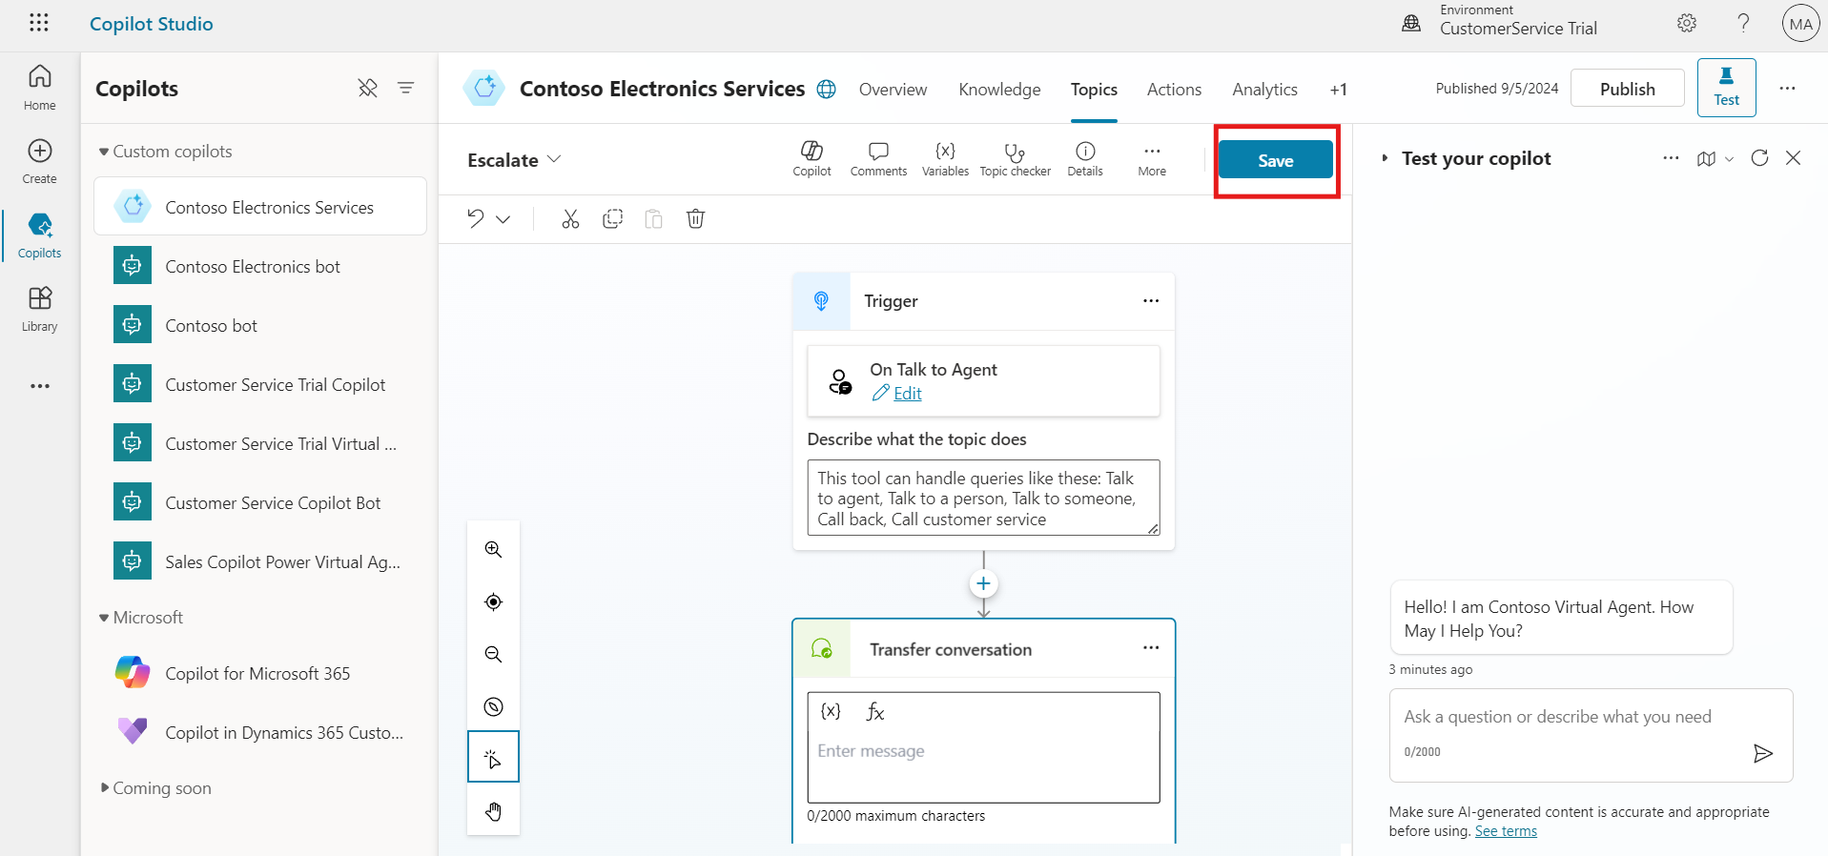

## Task 2: Activate the Copilot Channel

1. Navigate to **Copilot Studio** and open your **Contoso Electronics Services Copilot**.
2. Click on the **Channel** next to the action button.

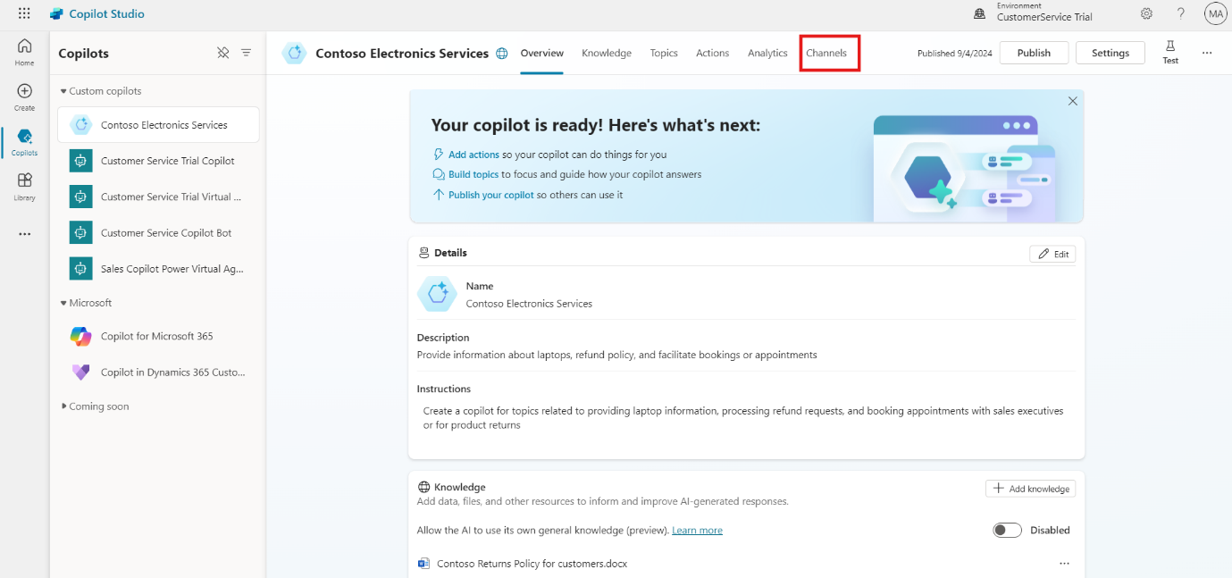

1. Scroll down and select **Customer Engagement Hub**.

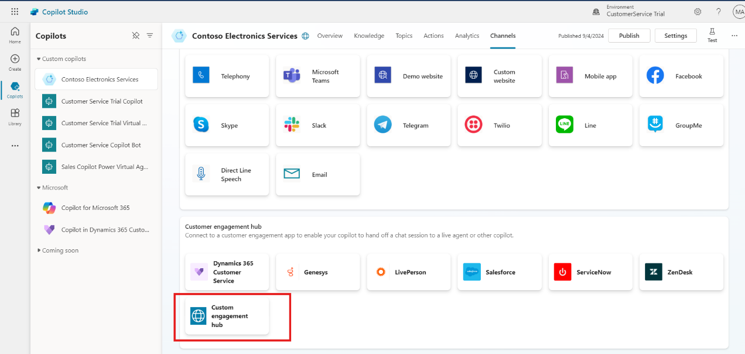

1. Click **Connect** to create a connection with Dynamics 365.

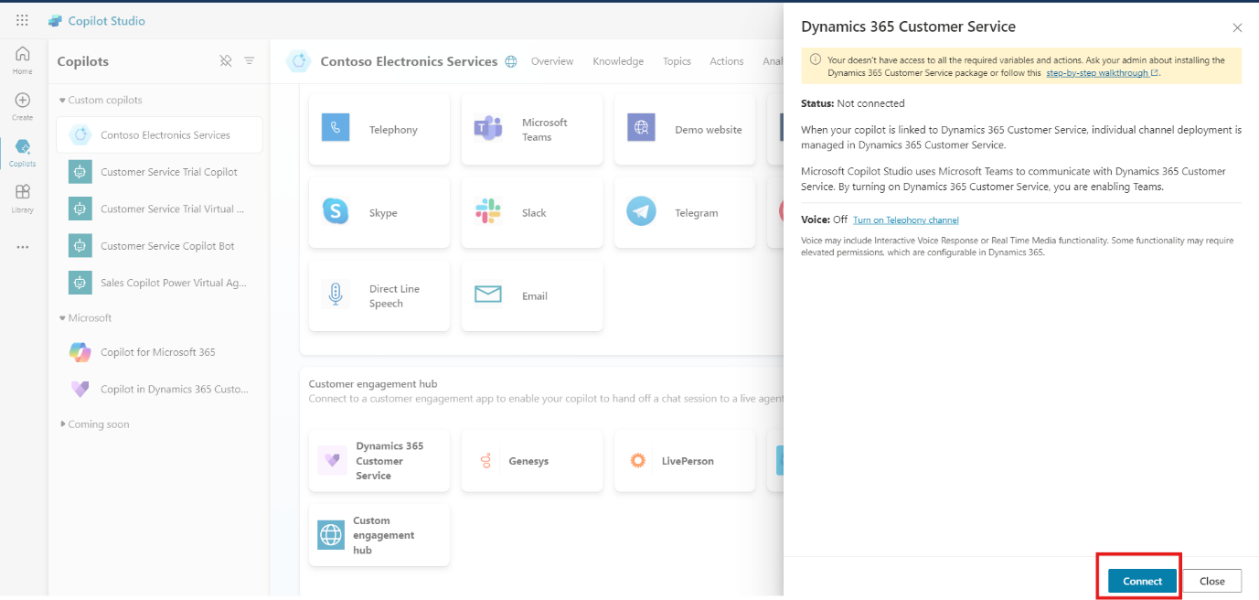

## Task 3: Publish Your Copilot

1. Navigate to Overview section and In Microsoft Copilot Studio, look for the **Publish** button on the right side of the screen.
2. Click on the **Publish** button to start the publishing process.

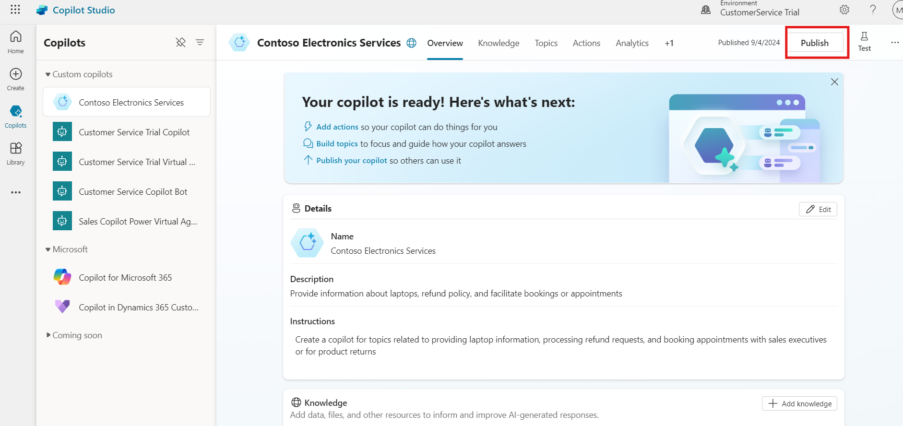

1. A confirmation dialog may appear. Select **Publish** again to finalize and publish your copilot.

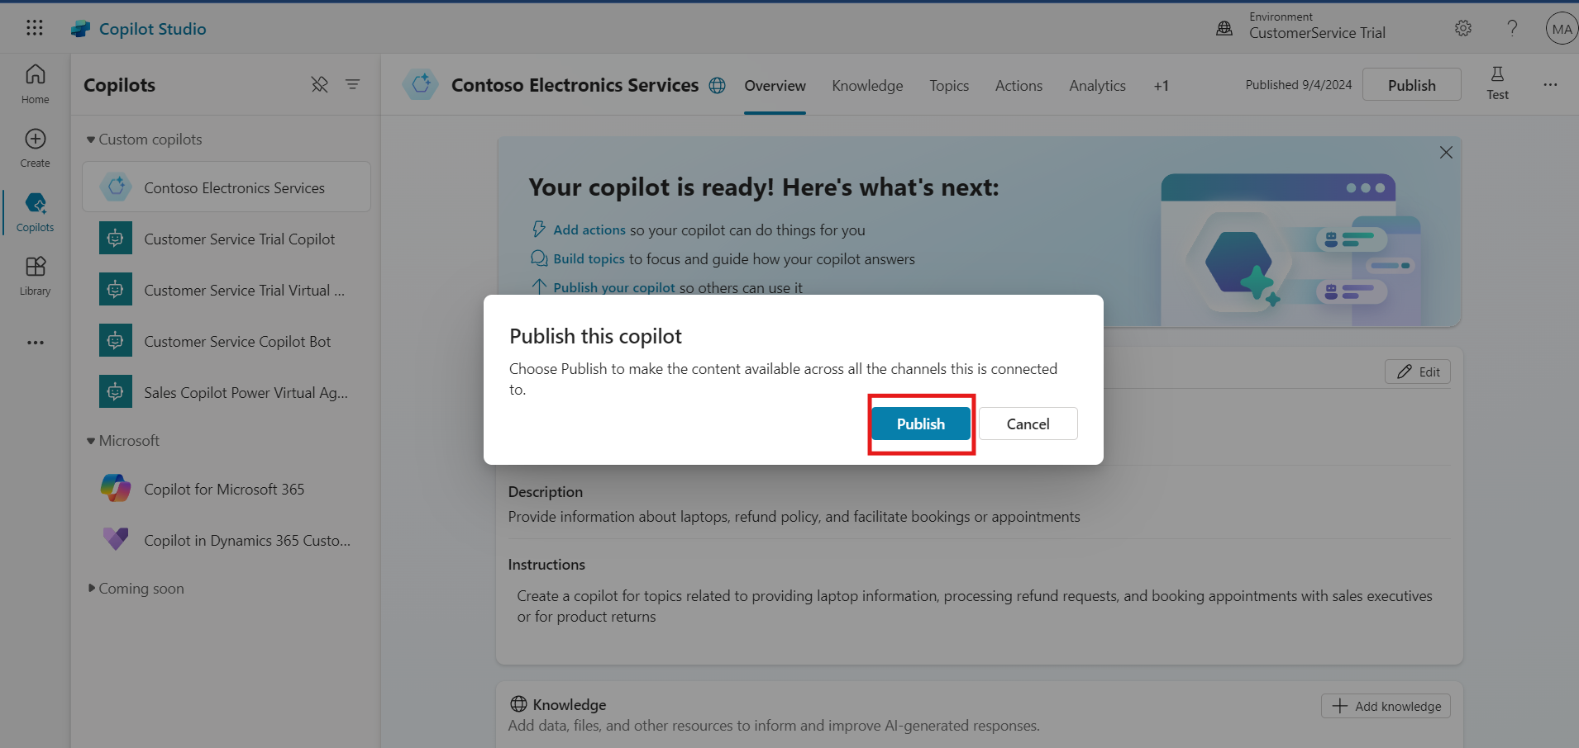

## Conclusion

After completing this exercise, you have gained the following knowledge:

1. Modified the "Escalate" topic by removing the message node and adding a Transfer Conversation node to facilitate escalation.
2. Established a connection between the Copilot and Dynamics 365 Customer Engagement Hub by selecting and connecting the channel.
3. Completed the publishing process to make the Copilot live and available for use.

These steps enhance the Copilot's functionality and integration with Dynamics 365, ensuring effective escalation handling and seamless communication.

# Exercise 3: Add and Activate Copilot Bot in Dynamic 365 Customer Service

In this exercise, you'll integrate your Copilot bot into Dynamics 365 by adding it to the Customer Service workspace. This process involves connecting the bot to the existing workstream and verifying its activation to ensure it is functioning correctly.

## Task 1: Add Bot in Dynamic 365 Customer Service

1. Navigate to **Dynamic 365 Customer service** and click on **Customer Service workspace** to explore the apps.

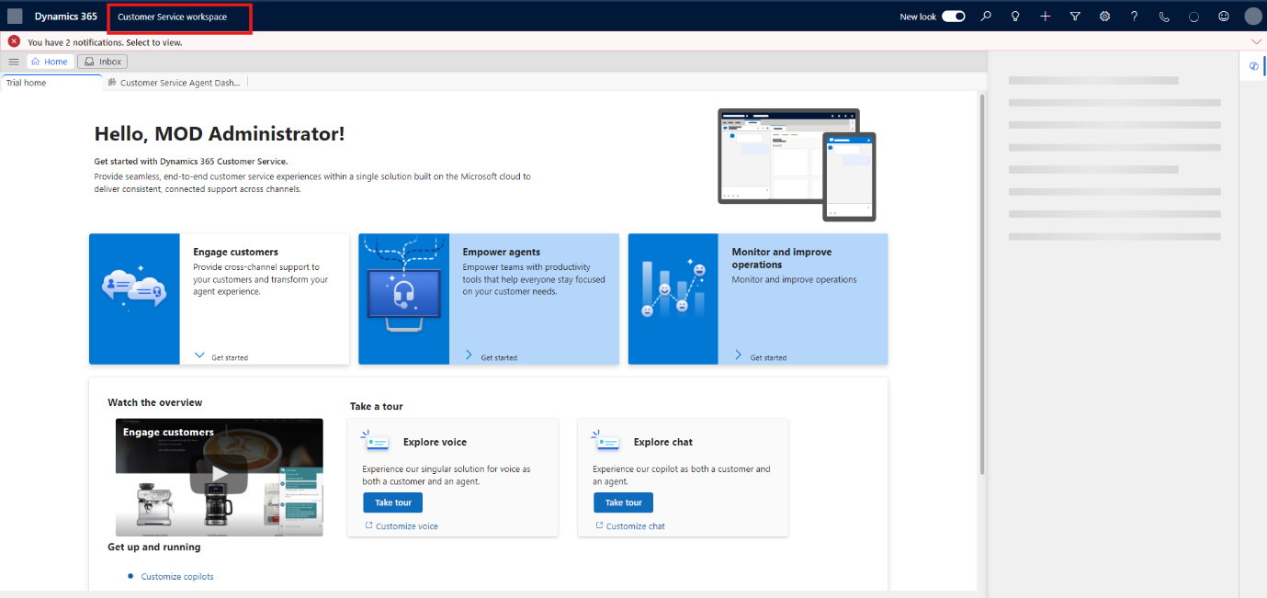

1. Locate and click on **Customer Service admin Center** within the workspace.

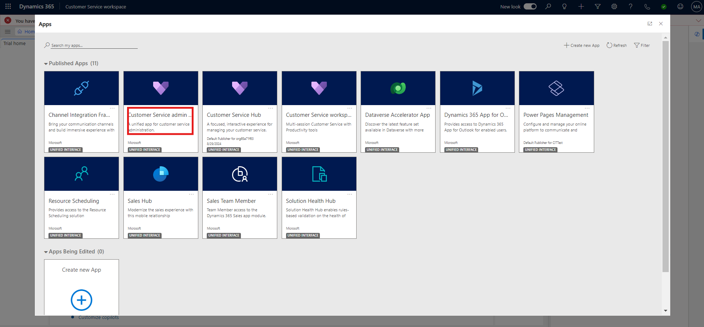

1. In the left navigation bar, click on **Workstream**, then select the **Contoso Agent** workstream created earlier.

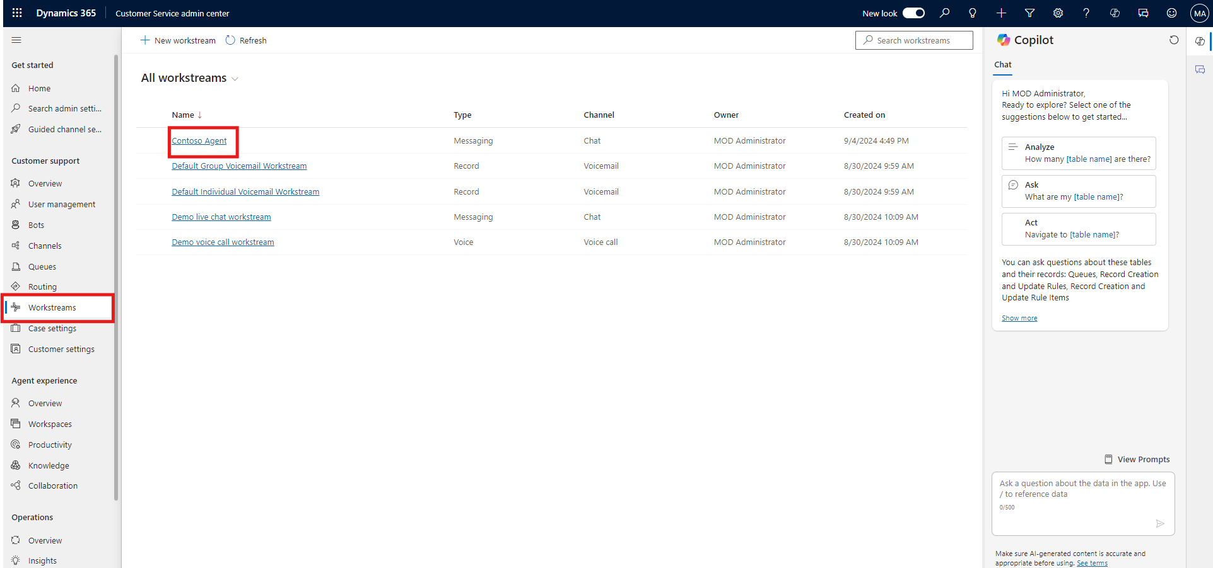

1. At the bottom, click **Add Bot**.

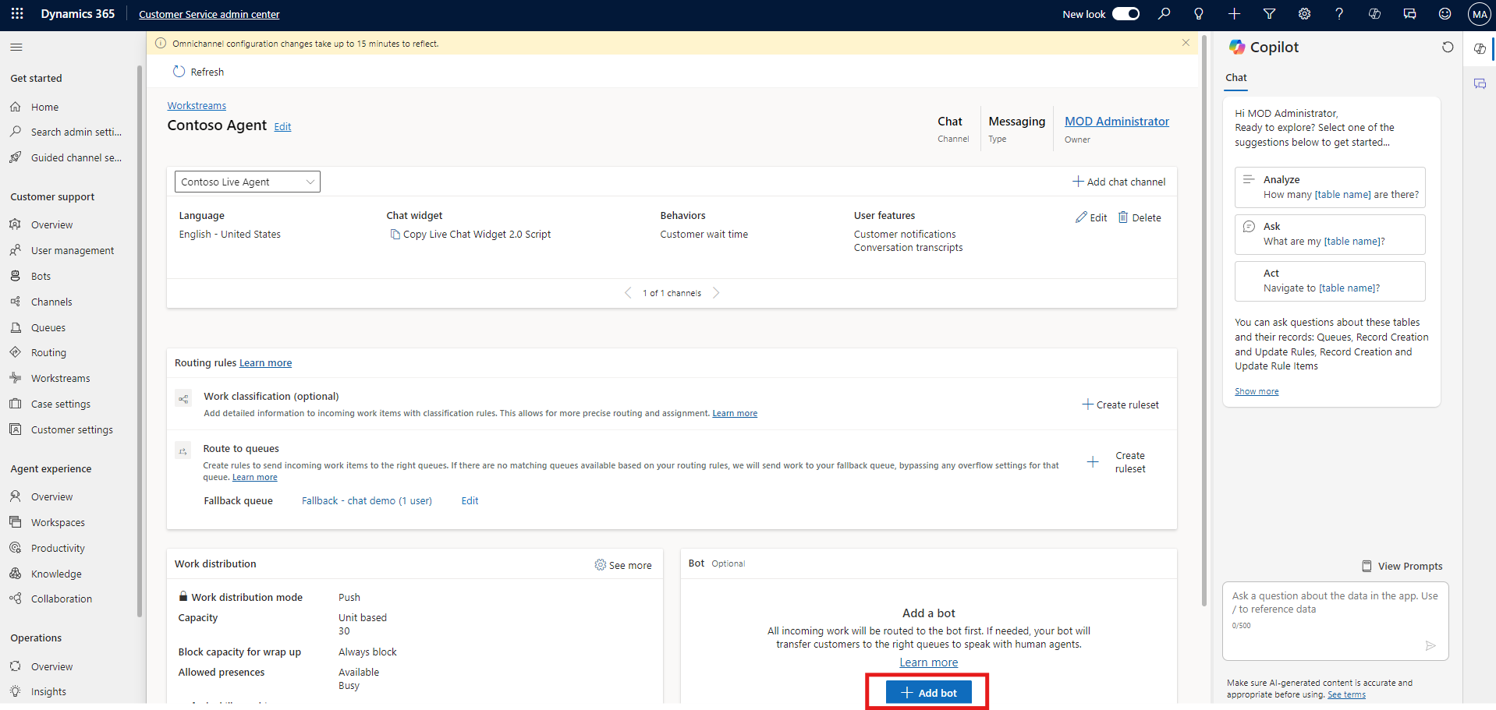

1. Select **Contoso Electronics Services** and click **Connect**.

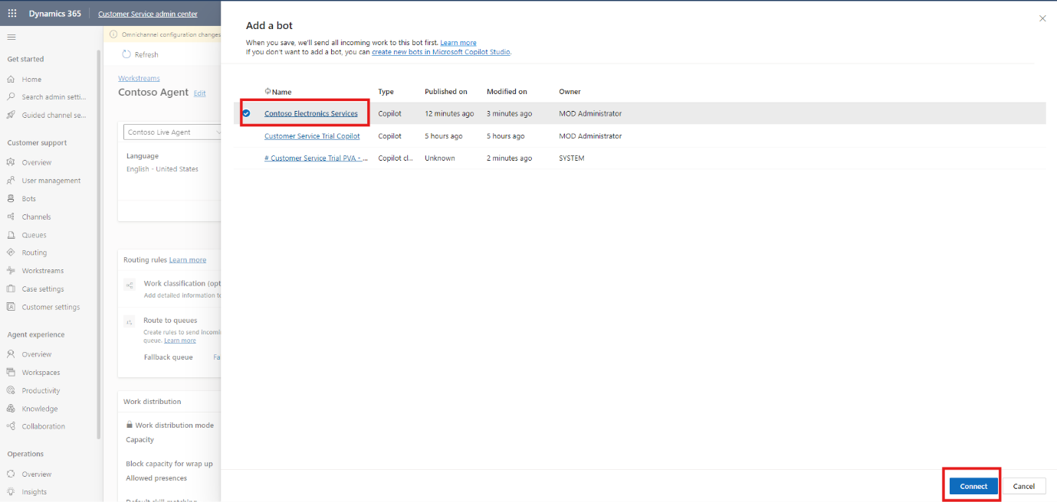

## Task 2: Check Bot Connection

1. In the left navigation bar, click on **Bot** and check that the **Contoso Electronics Services** bot is Connected.

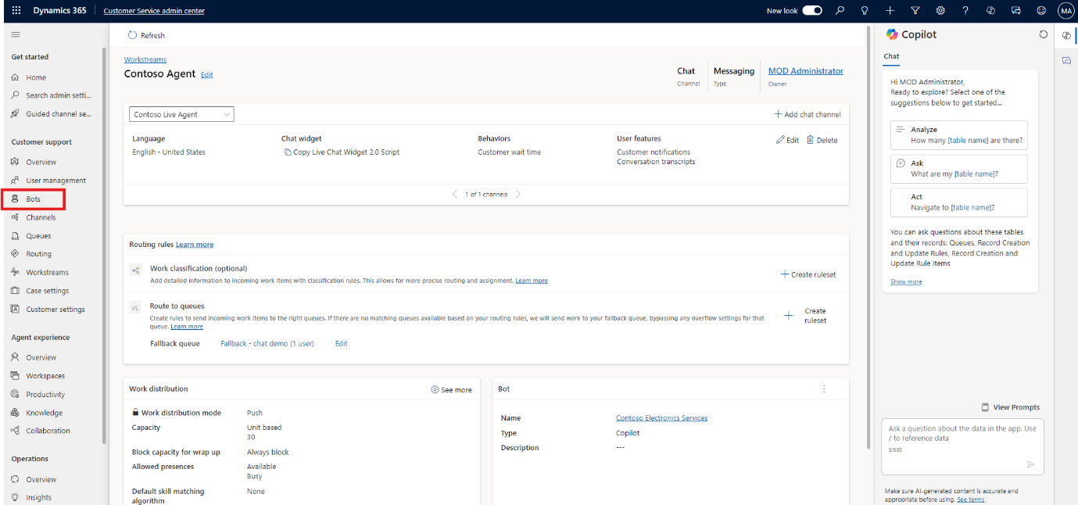

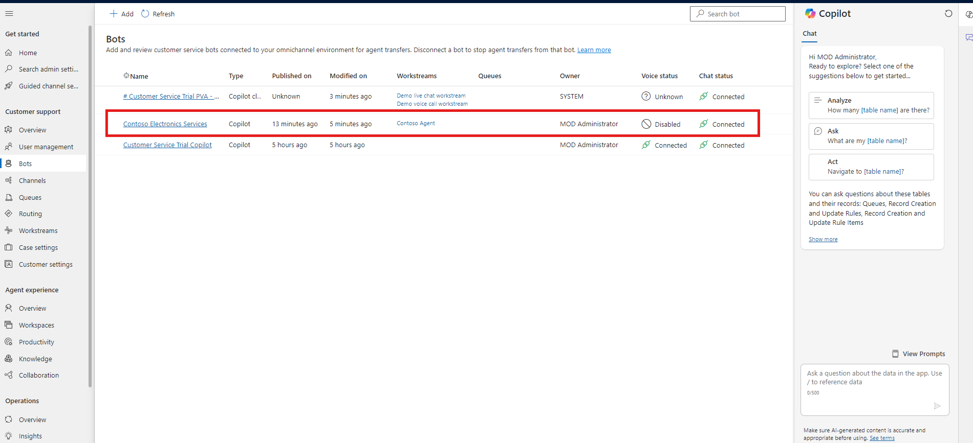

## Conclusion

After completing this exercise, you have gained the following knowledge:

1. Integrated the "Contoso Electronics Services" bot into the "Contoso Agent" workstream by connecting it within the Customer Service admin center.
2. Verified that the bot is active and functioning correctly in the Bot section of the Dynamics 365 interface.

This process ensures that your Copilot bot is effectively integrated and operational within Dynamics 365, ready to handle customer interactions through the configured workstream.

# Exercise 4: Deploy Copilot on a Power Page Website

In this exercise, you'll deploy your Copilot bot onto a Power Page website. This involves connecting the bot with Power Pages, adding the necessary code to the website, and previewing it to ensure everything is functioning as expected.

## Task 1: Connect Bot with Power Pages

1. Visit <https://www.microsoft.com/en-us/power-platform/products/power-pages> and sign in with the ID and password which we use early exercises.

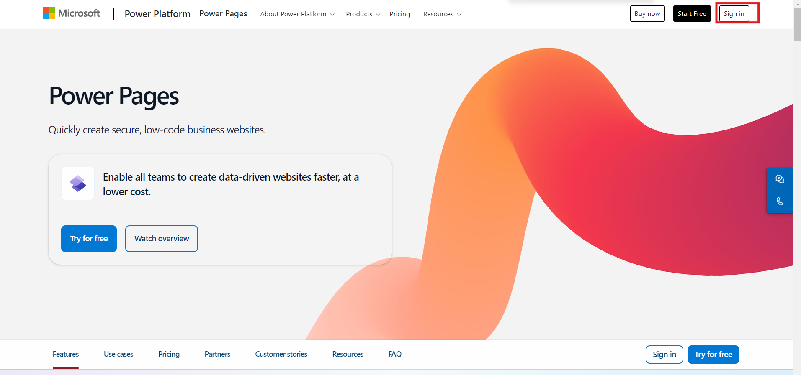

1. From the top right corner, select the correct environment **CustomerService Trial.**

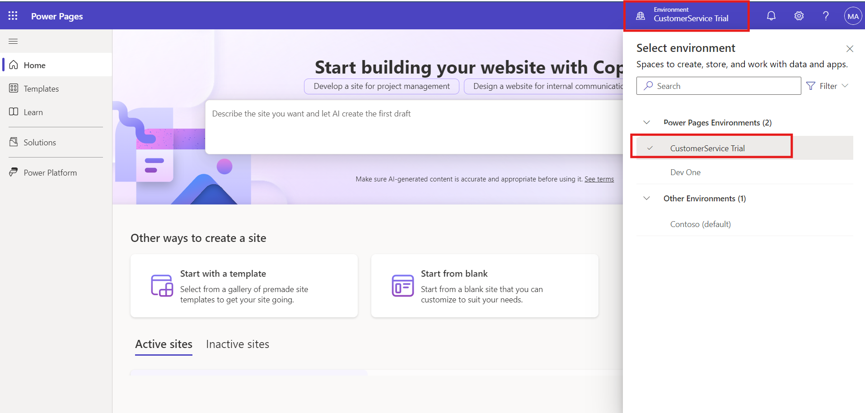

1. Scroll down and select **Start a template**.

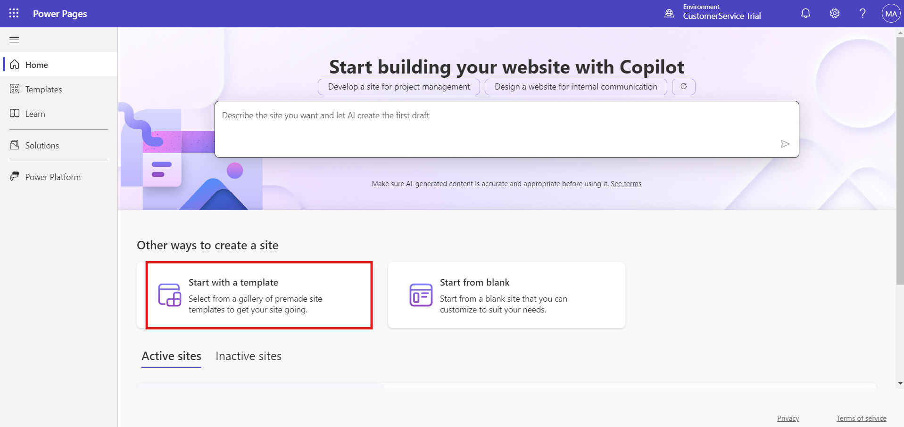

1. Choose a template, name the website **Contoso**, and click **Done**.

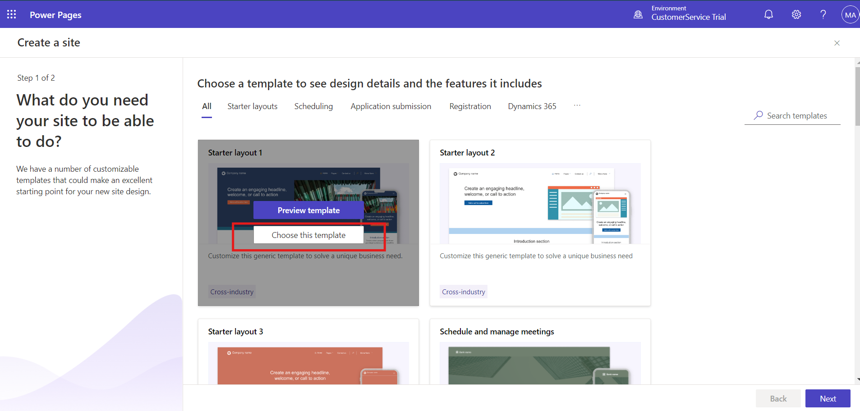

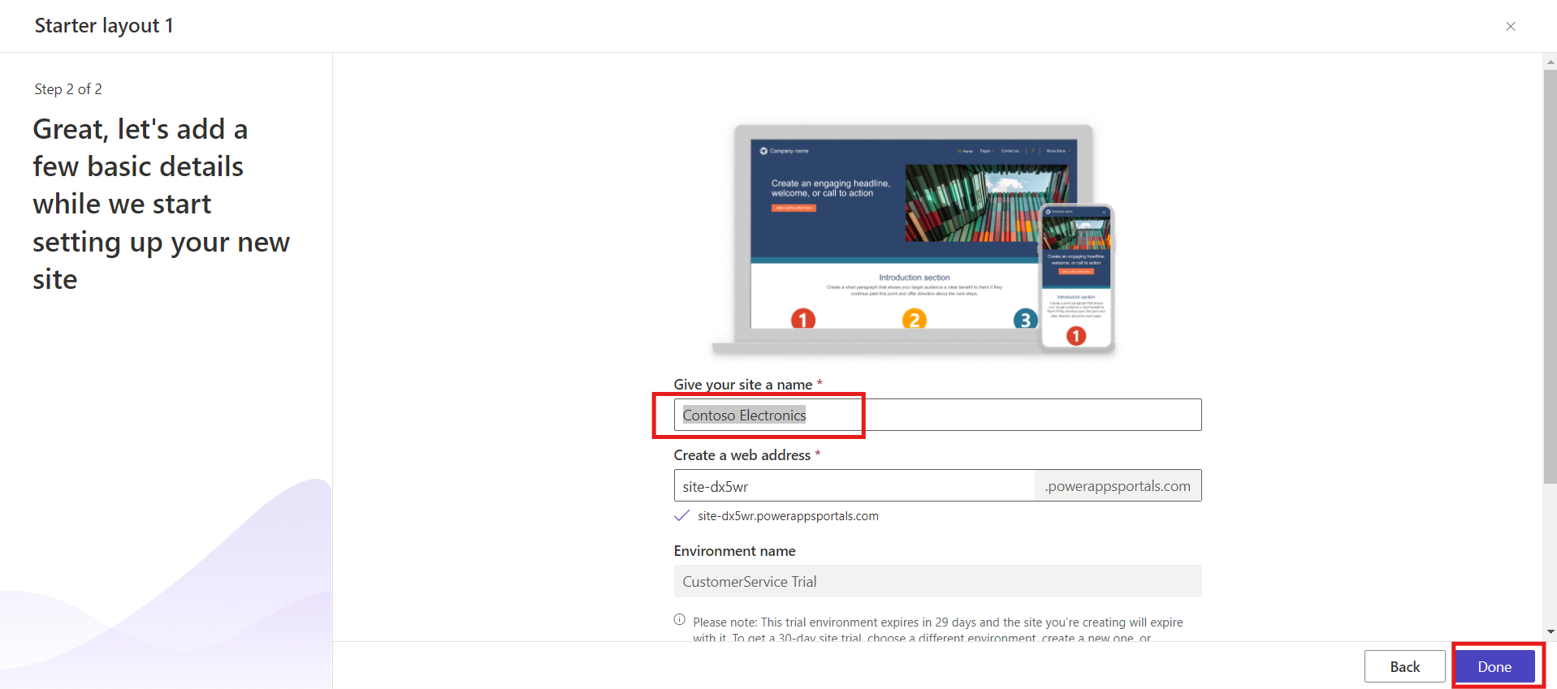

1. Click **Edit Code** and then **Open Visual Studio Code**.

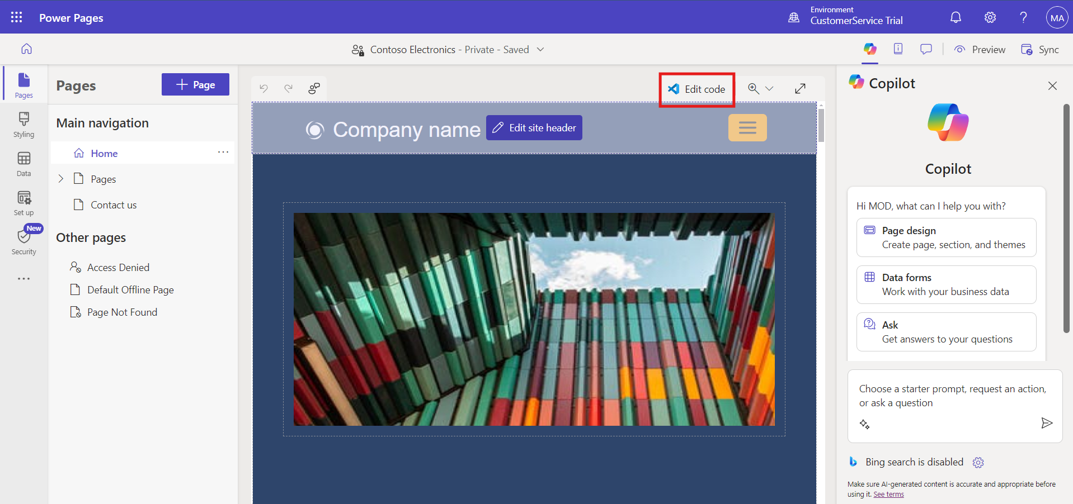

1. Sign in to Visual Studio Code when prompted.

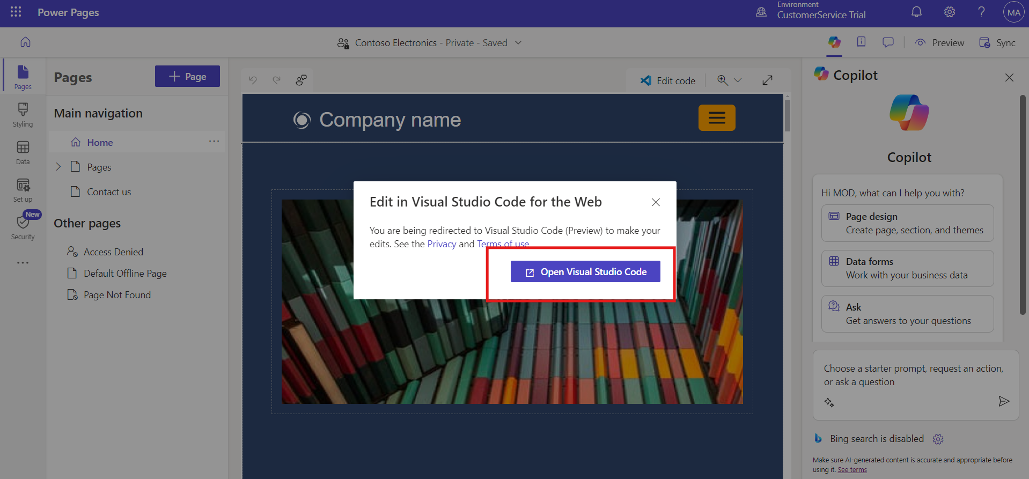

1. Paste the widget code (copied earlier) at the bottom of the website home page code.

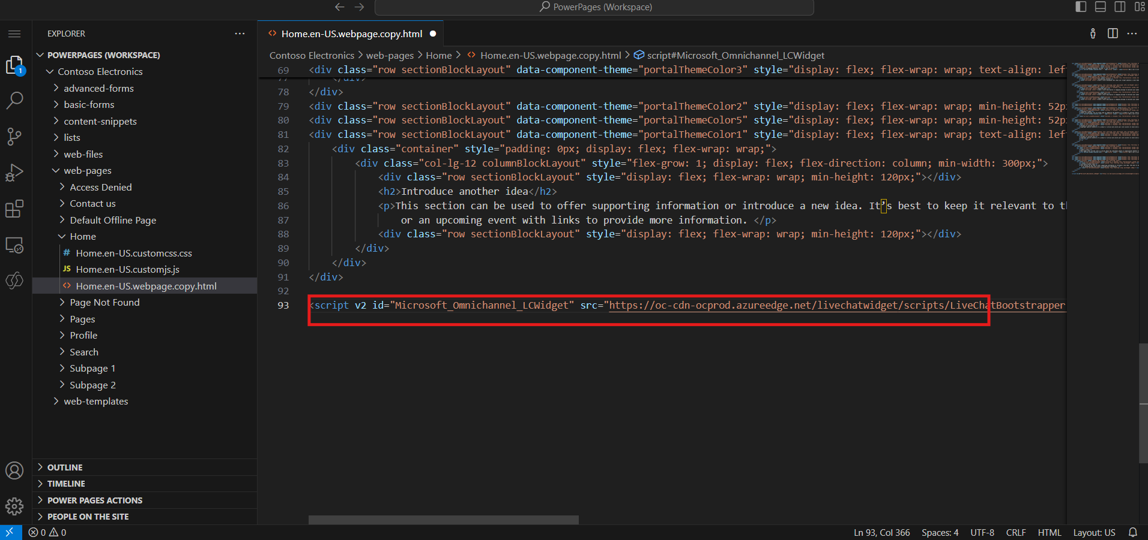

1. Save the file with **Ctrl + S**. Return to the Power Pages window and click **Sync**.

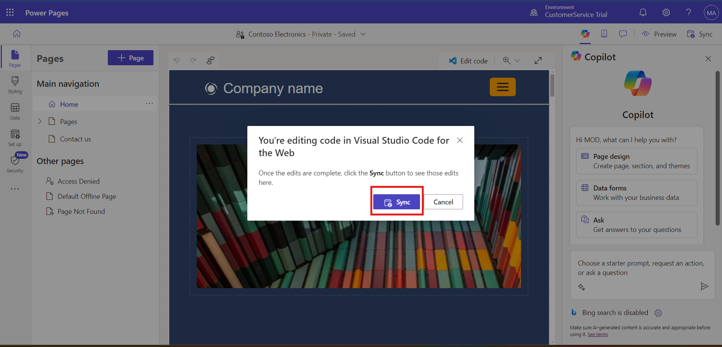

1. Click **Preview** and then **Desktop** to preview the website. The **Contoso Agent** bot will appear at the bottom.

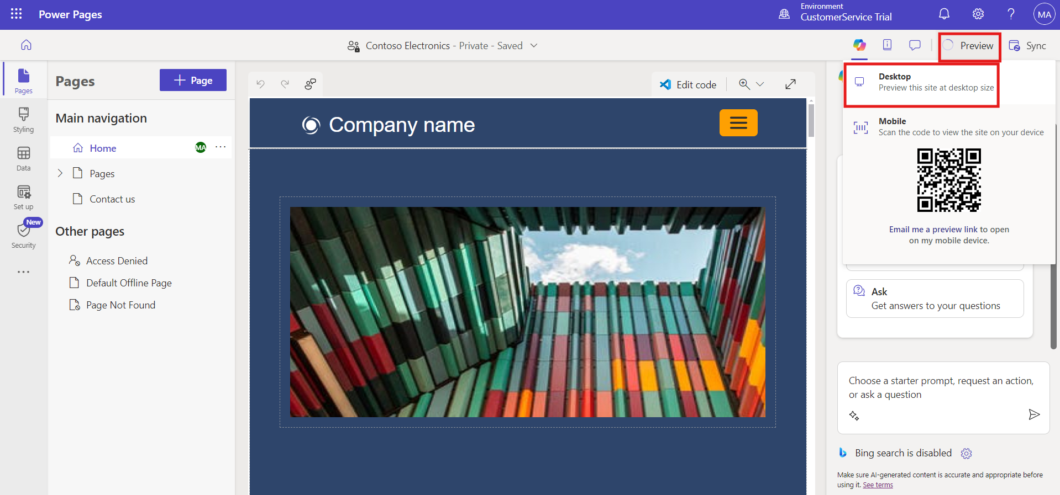

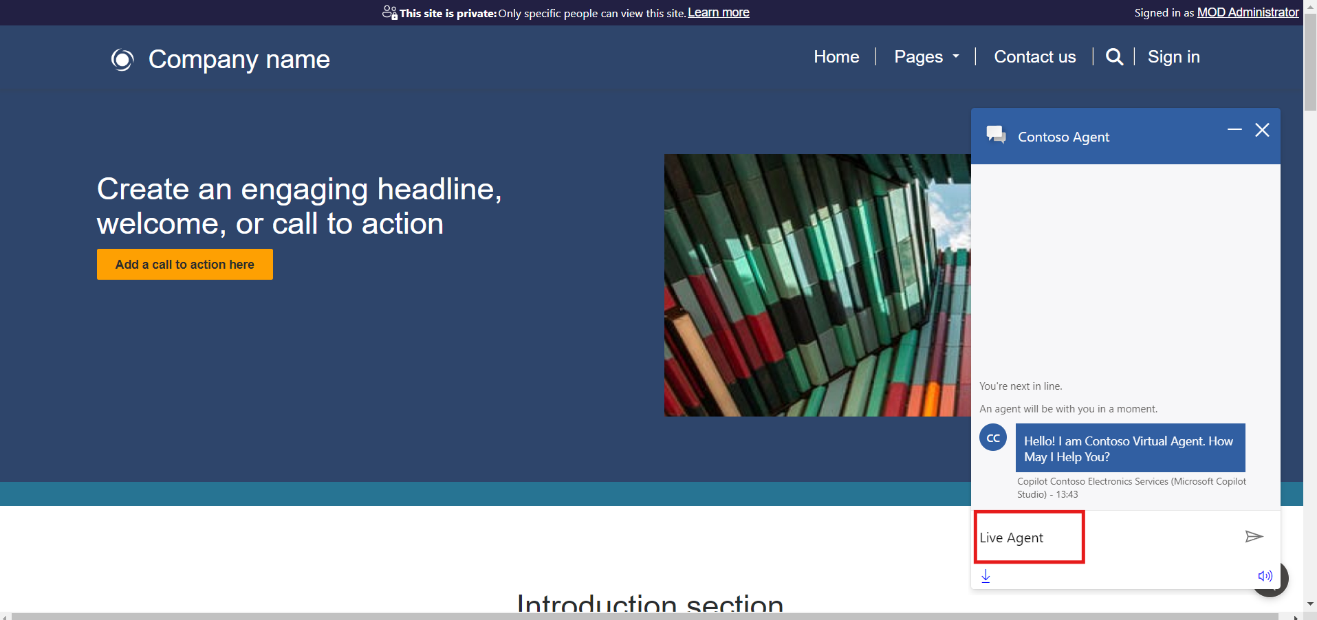

## Conclusion

After completing this exercise, you have gained the following knowledge:

1. Logged into Power Pages, created a website using a template, and integrated the Copilot bot by adding the widget code to the website's home page code.
2. Saved the code changes, synced with Power Pages, and previewed the site to ensure the "Contoso Agent" bot appears and functions correctly.

This deployment ensures your Copilot bot is live and operational on the Power Page website, providing a seamless customer interaction experience.

# Test Live Agent

In this exercise, you'll test the live agent functionality by interacting with the Contoso Agent bot deployed on the Power Pages website. This will involve initiating a live agent chat request from the website and managing the interaction within the Dynamics 365 Customer Service workspace.

1. Go to Dynamics 365 and select **Customer Service workspace** and then select **Customer Service workspace** App to open and explore the apps.
2. In another window, open the Power Pages app and preview the website created in the previous step.
3. Open **Contoso Agent** on the Power Pages website.
4. Type **Live agent** in the chatbot.



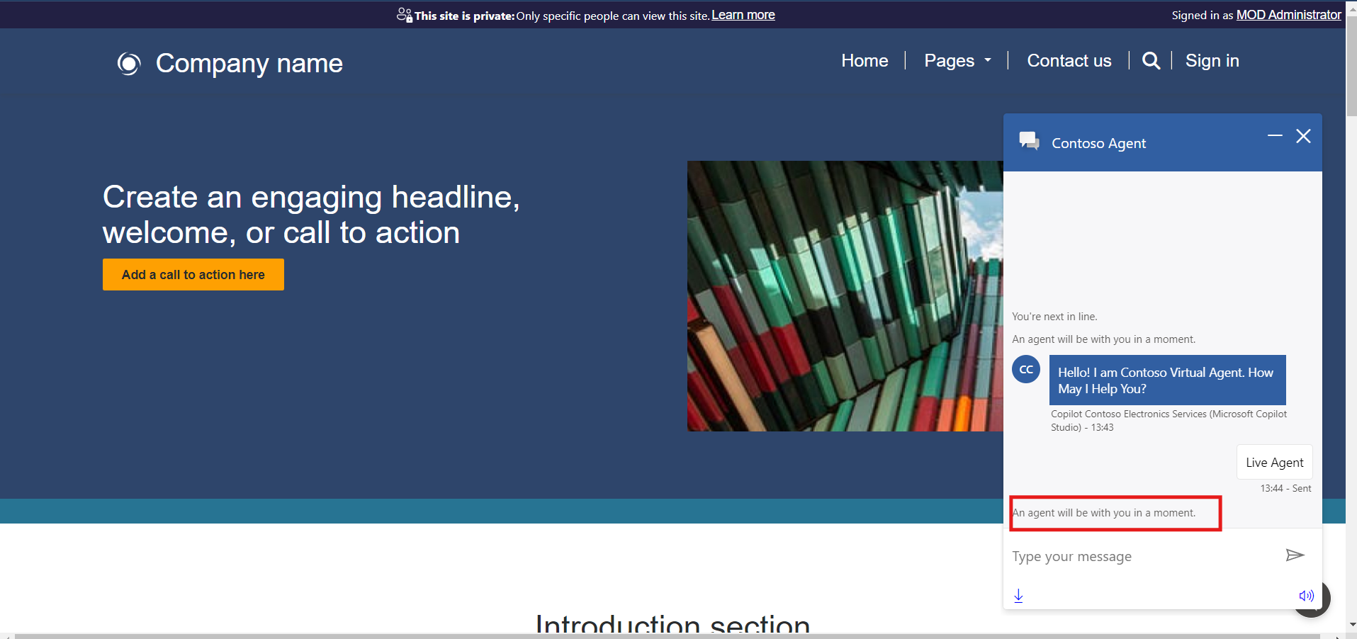

1. Open a new window, go to the Dynamic 365 customer service and click on the customer service admin center the app window will open. In App window select Customer Service Workspace.
2. The live agent chat request will be sent to the **Customer Service workspace,** where the live agent can accept or reject the request. (If request not seen there, refresh the power page preview and again type live agent in the Contoso chat bot).

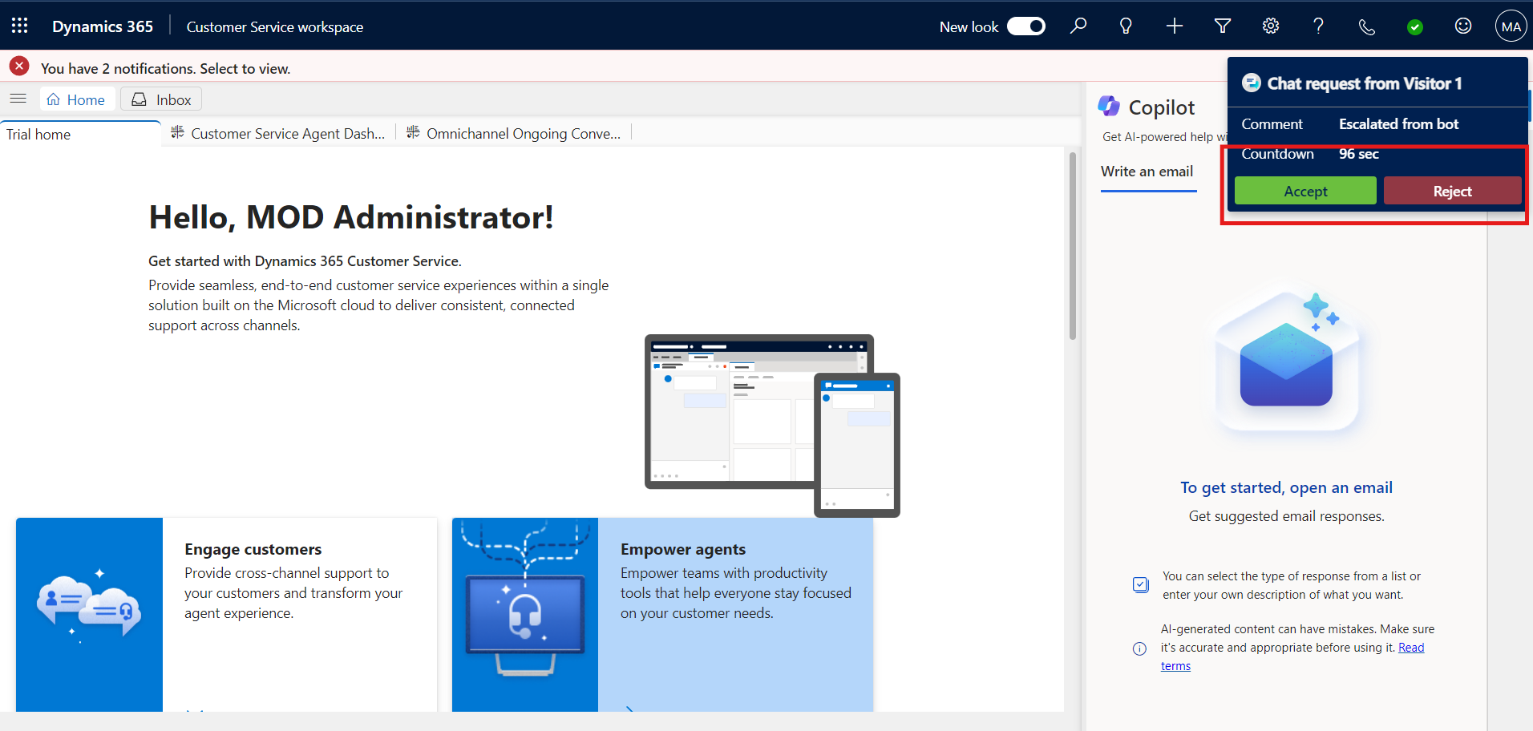

1. Live agent accepts the request and start conversation.

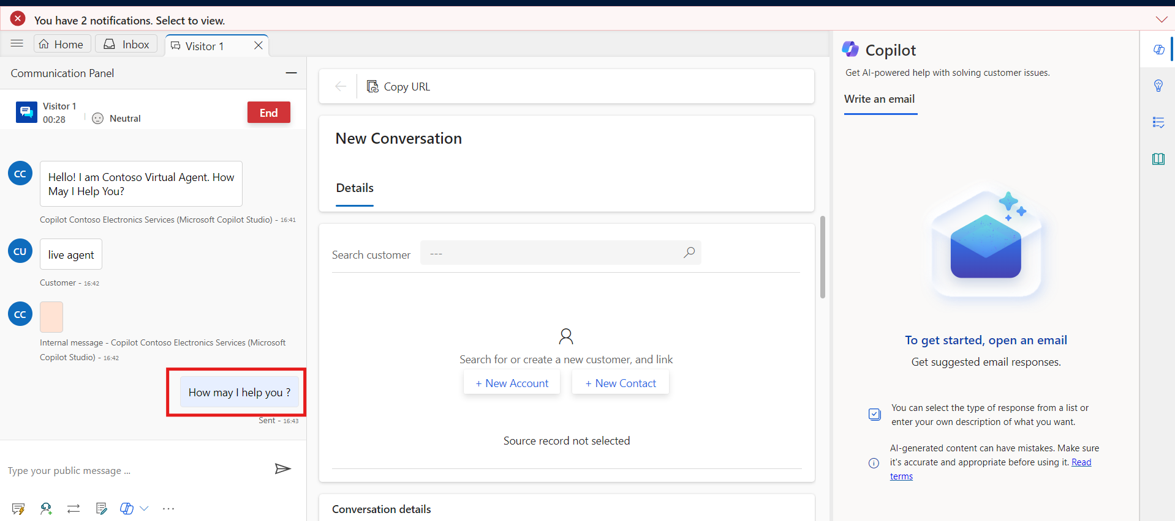

1. Customer reply to live agent.

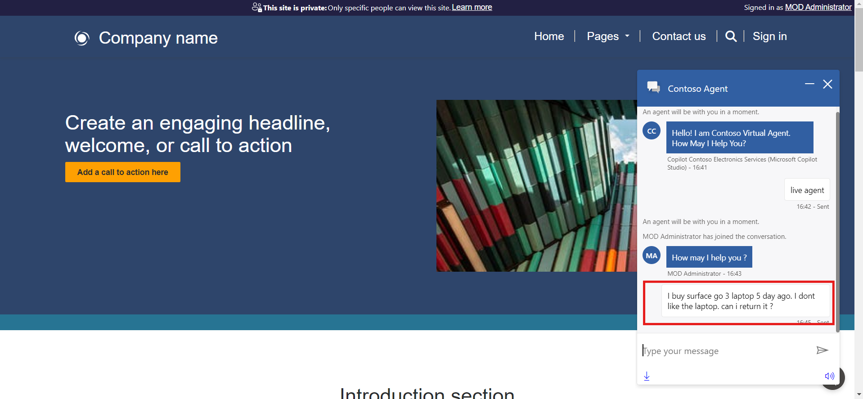

1. Contoso Electronic live agent replies.

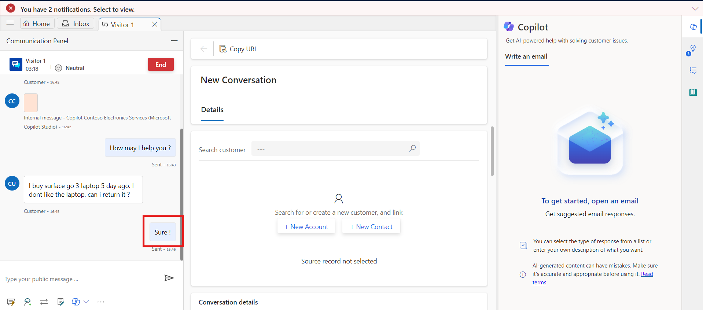

# Final Conclusion

In conclusion, the comprehensive steps undertaken in configuring and deploying Dynamics 365 and the Copilot have led to a highly efficient and integrated customer service solution.

1. **Configured Dynamics 365:** Successfully signed in, created a new workstream, and configured a chat channel to manage customer interactions efficiently.
2. **Enhanced Copilot Functionality:** Configured escalation topics connected the Copilot with Dynamics 365 and activated the Copilot channel to streamline customer service operations.
3. **Integrated Copilot Bot:** Added and verified the Copilot bot within the Dynamics 365 Customer Service workspace, ensuring it was properly connected and active.
4. **Deployed Copilot on Power Pages:** Connected the bot with Power Pages, integrated it into the website, and previewed the deployment to confirm its functionality.